**Bank CRM - SQL Project**

**OBJECTIVE QUESTIONS**

1.)What is the distribution of account balances across different regions?

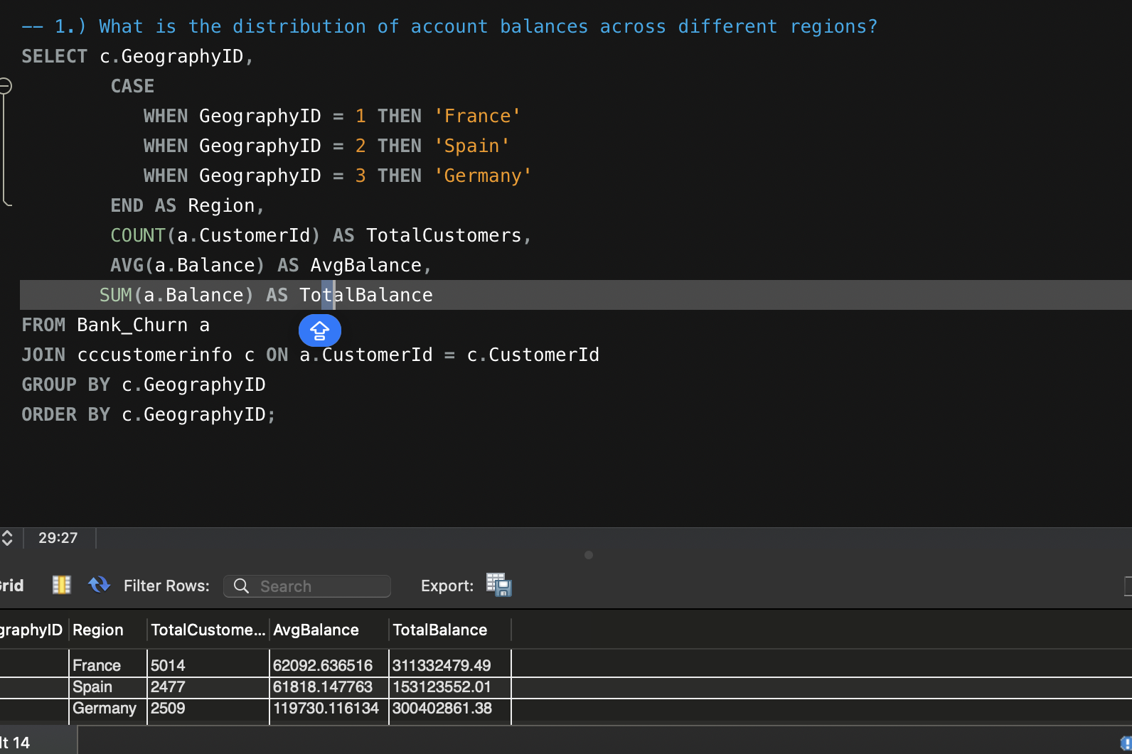

Solution :-- Average distribution of account balance across France is 60092.63, Spain is 61818.147, and across Germany is 119730.11

Insights:-- From the analysis we can see that Average account balance of customers staying in Germany is greatest.

Approach :-- To find the solution here we have to join 2 tables on common column customer id and group it by geography id , and find the average of balance of customers to find the solution.

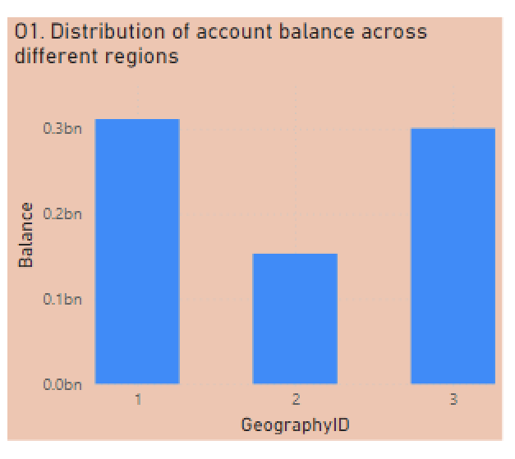

2.)Identify the top 5 customers with the highest Estimated Salary in the last quarter of the year. (SQL)

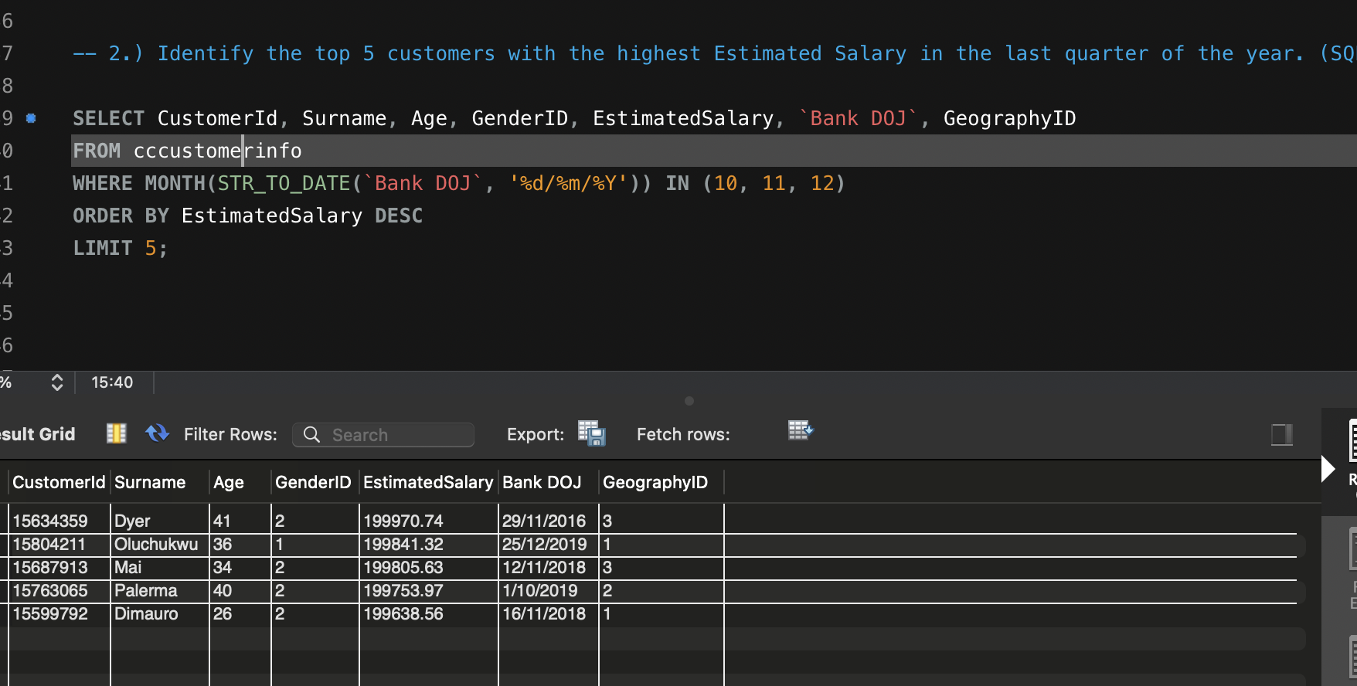

Solution:-- Top 5 customers with highest estimated salary are with surname Dyer, Oluchukwu, Mai, Palema, Dimauro.

Insight:-- Here we can see that customer having surname Dyer has the highest estimated salary and belongs to Geography ID 3.

Approach:-- To find the solution here we to take estimated salary from cccustomerinfo table and order the estimated salary in descending order and apply Limit 5 to find top 5;

3.)Calculate the average number of products used by customers who have a credit card. (SQL)

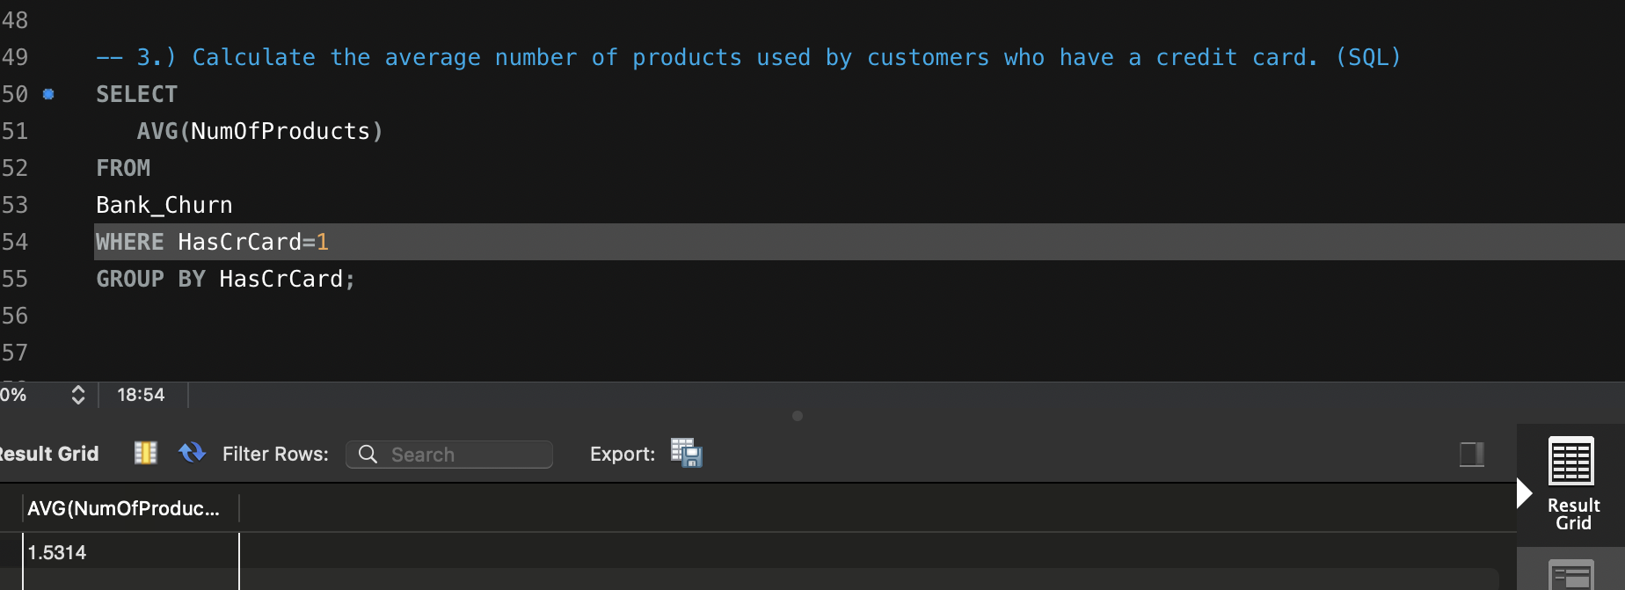

Solution:-- As we can clearly see from sql query, that average number of products used by customers who have credit card is 1.5314.

Insight:-- hat average number of products used by customers who have credit card is 1.5314.

Approach:-- here we will take average of NumOfProducts fro Bank_Churn table and apply a filter where HasCrCard=1.

4.) Determine the churn rate by gender for the most recent year in the dataset.

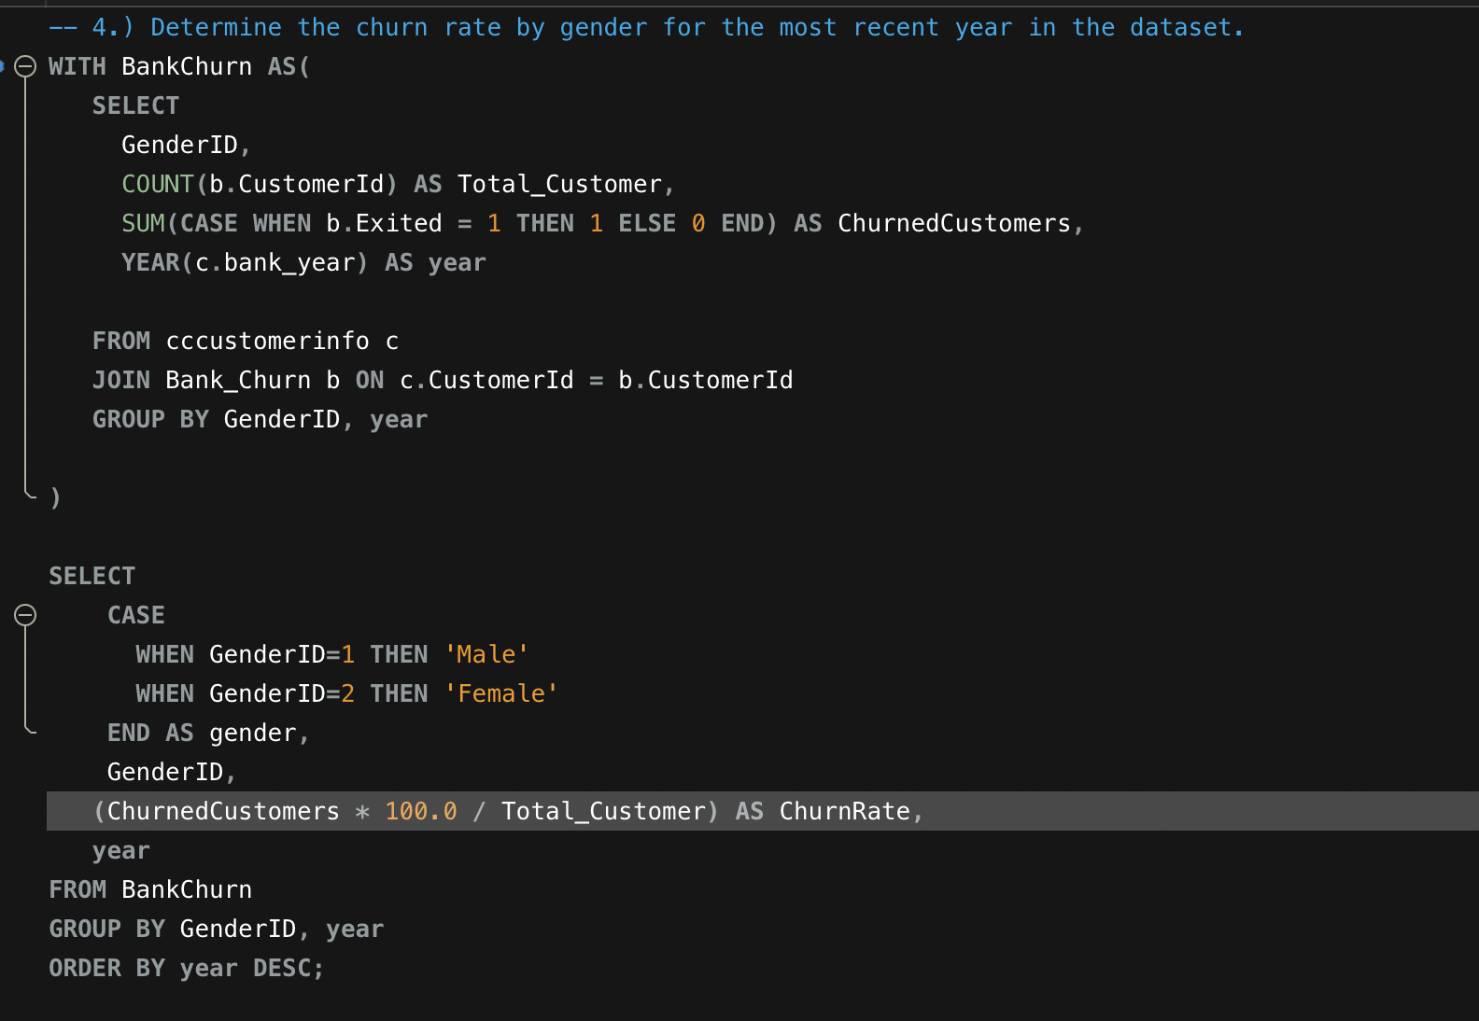

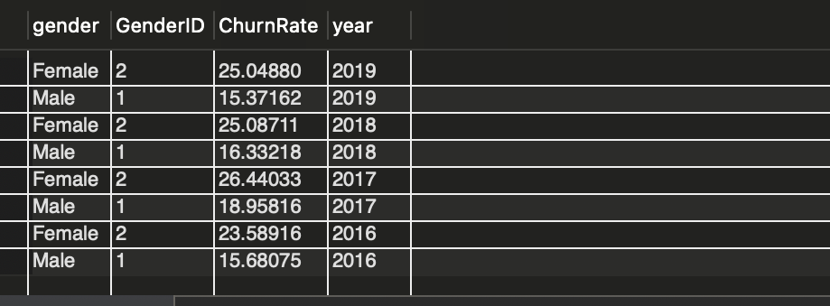

Solution:-- Churn rate by gender in year 2019 for female customers is 25 % and for male customers is 15.37.

Insight:-- The data shows that female customers tend to show higher churn rate as compared to males.

Approach:-- Here we will apply CTE (common table expression) and from that we will fine the churn rate by gender.

5.) Compare the average credit score of customers who have exited and those who remain. (SQL)

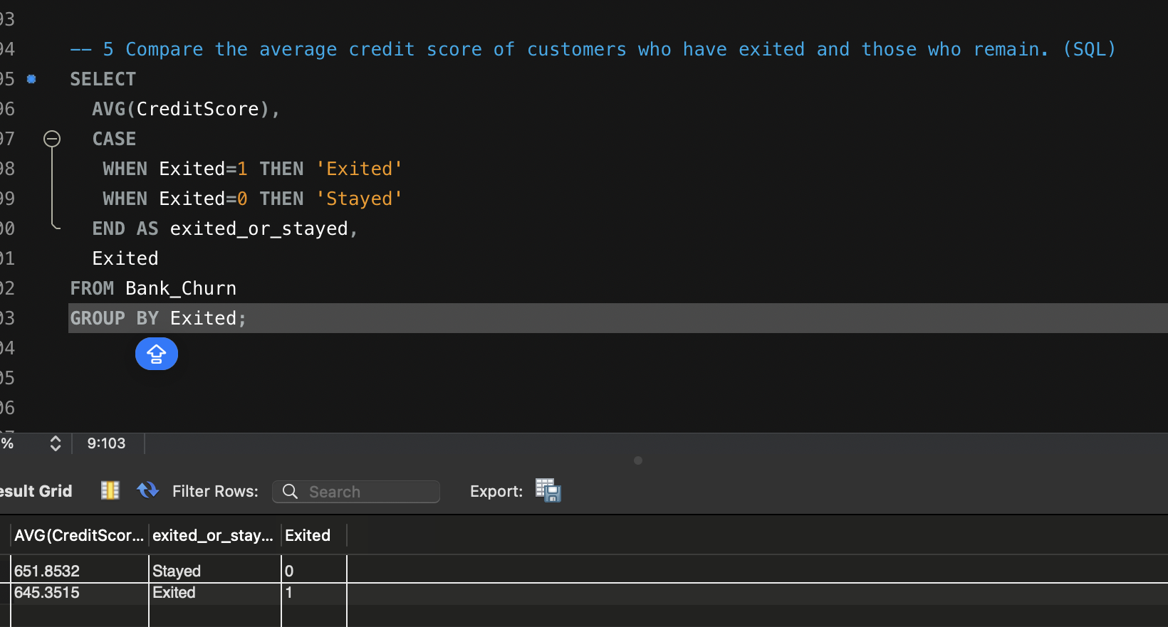

Solution:- Average credit score of customers who have stayed is 651.85 and those who exited is 645.3515.

Insight:- From this we can clearly see that average credit score of customers how are still with the bank is greater as compared to those who have exited.

6.) Which gender has a higher average estimated salary, and how does it relate to the number of active accounts? (SQL)

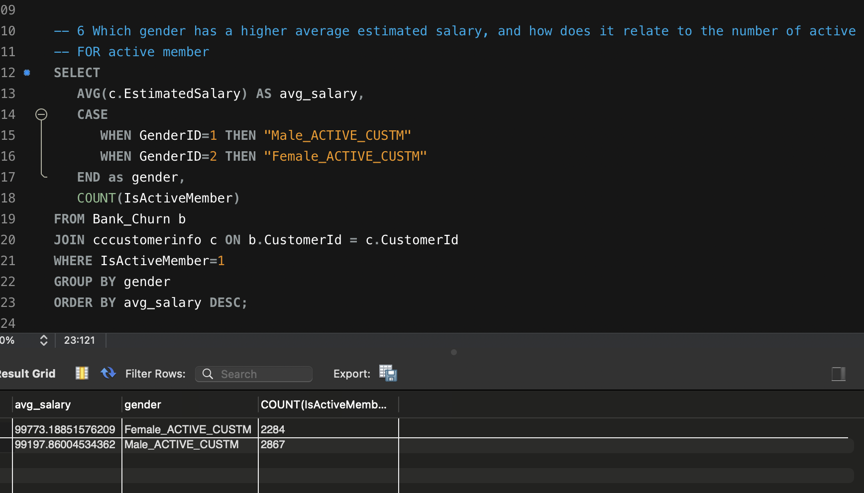

Solution:- Female has higher average estimated salary.

Insight:- Though female and male tends to have almost equal estimated average salary, the difference in there salary is very minute. And there seems to be no relation of estimated salary with the number of active accounts.

7.) Segment the customers based on their credit score and identify the segment with the highest exit rate. (SQL)

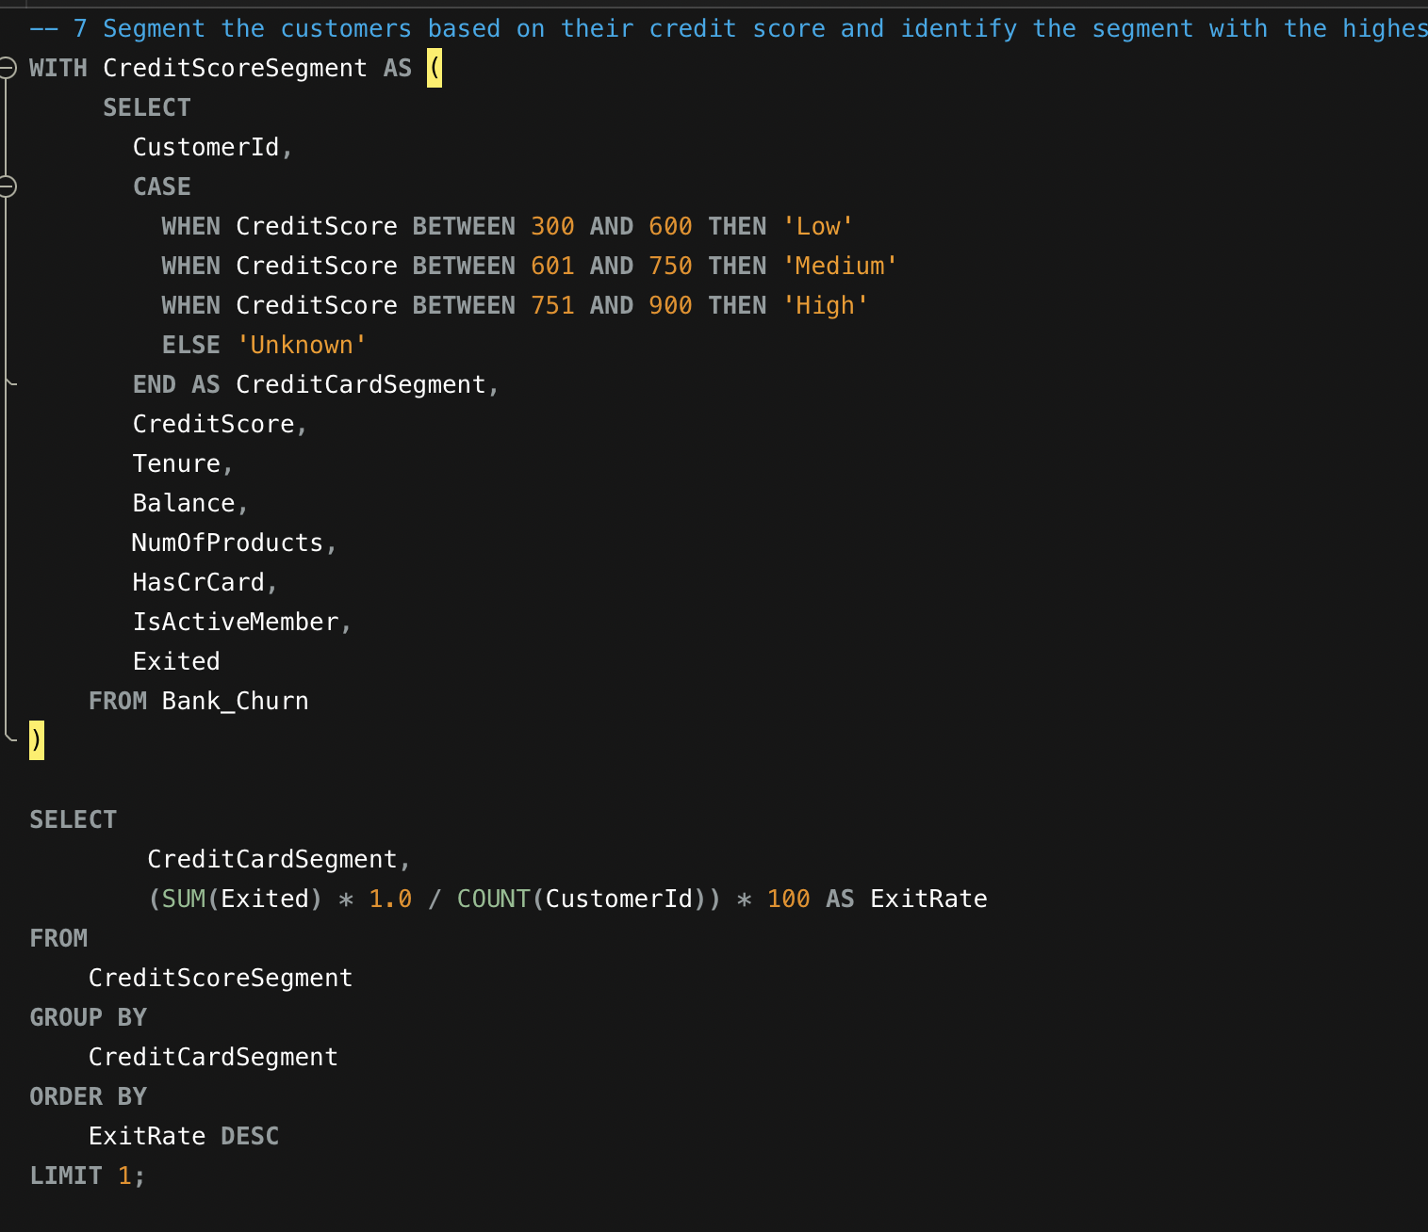

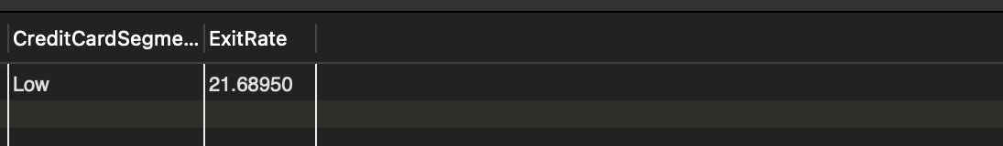

Solution:- Data shows that customers having a low i.e between 300 to 600 credit score tend to show higher exit rate.

-> So banks Should use credit card service to retain customers.

8.) Find out which geographic region has the highest number of active customers with a tenure greater than 5 years. (SQL)

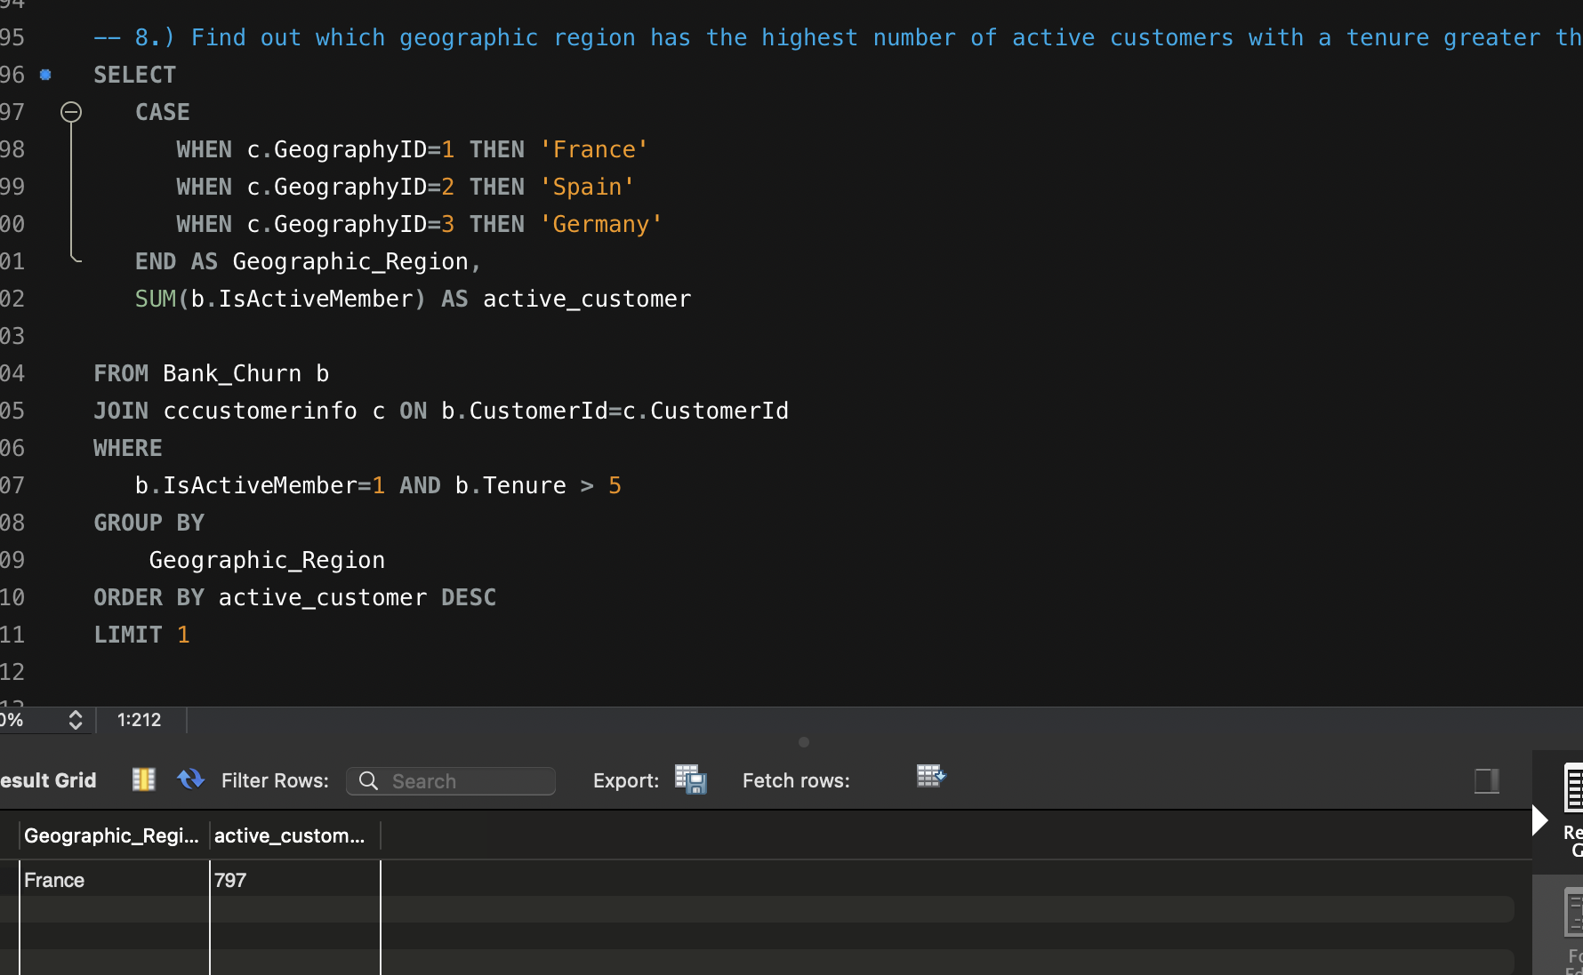

Solution:-

1. Data Shows that France has the highest number of active customers i.e 797 with a

Tenure greater than 5 years.

1. The region in which bank show low tenure should try to increase customer retention by introducing various schemes such as customer loyalty program, home loan, education loan, car loan etc.

9.)What is the impact of having a credit card on customer churn, based on the available data?

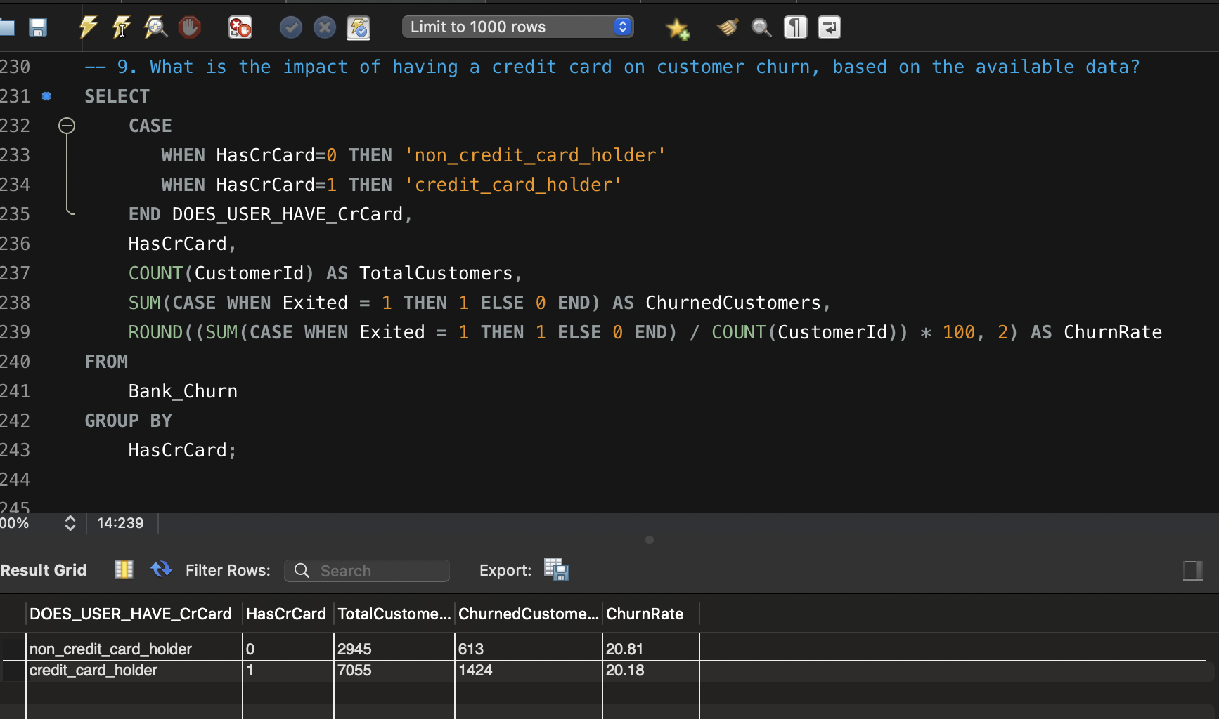

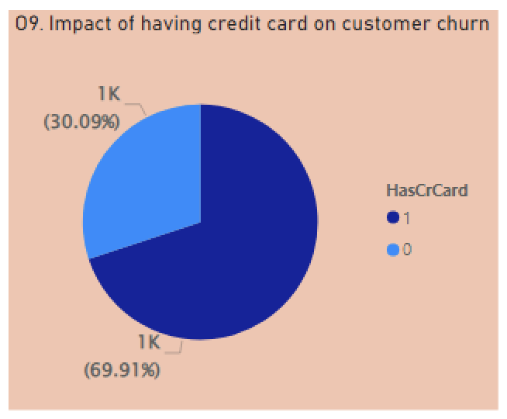

1. Customers who have credit card tend to show lower churn rate i.e 20.18 % as compared to customers who don’t have customers who don’t have credit card.
2. Also form the above pie chart it is clear that customers who do not hold the credit card tend to show higher churn rate . So bank should try to provide customer credit card to help reduce the churn rate of customers and increase retention rate of customers. Also banks can introduce various schemes and programs to reduce churn rate.

10.) For customers who have exited, what is the most common number of products they have used?

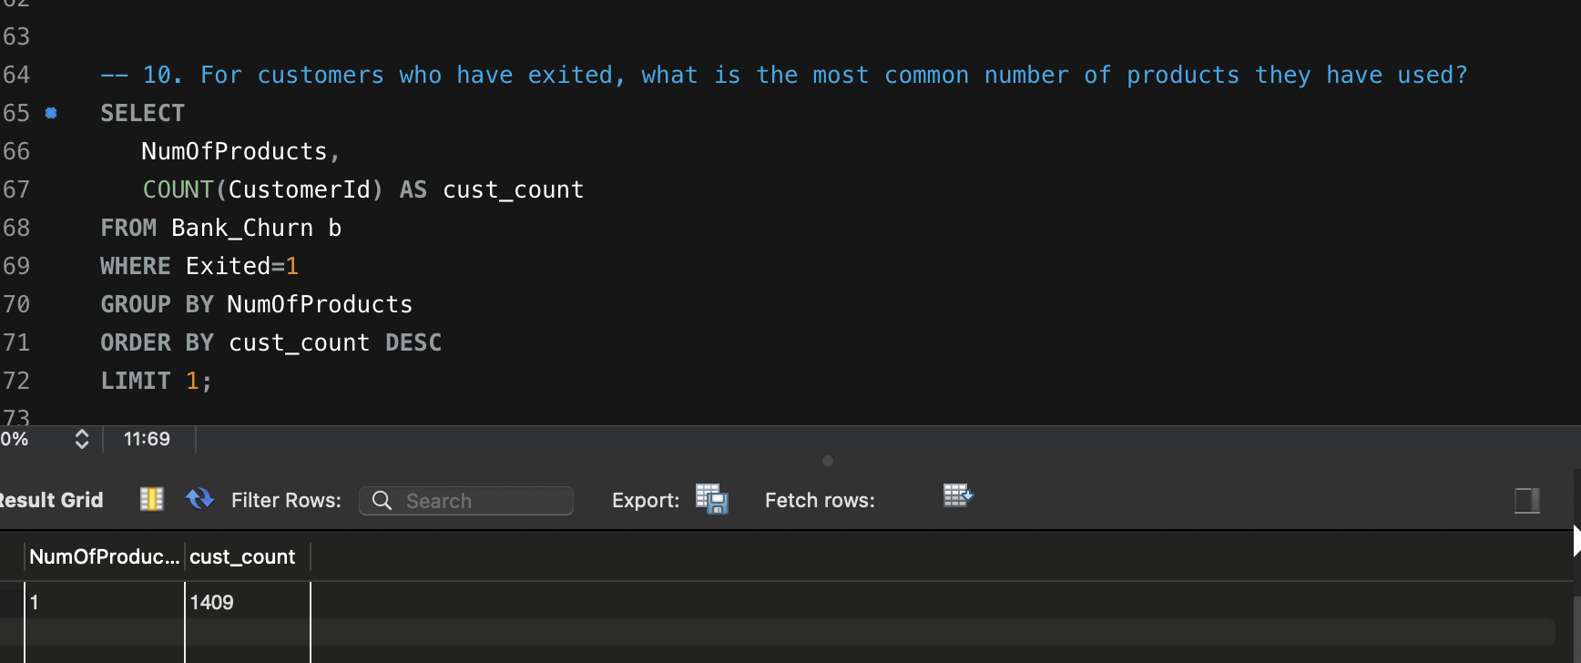

Ans:-- ) Insights:- For the customers how have exited (1409 customers) , common number of products used by those customers is 1.

Recommendations :- the clearly shows that if we want to reduce the churn rate, bank should try to engage customers more with the bank and convince them to use more number of products and services from the bank.

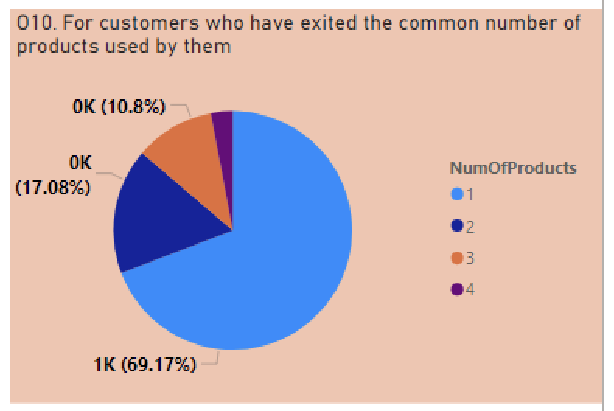

11.) Examine the trend of customers joining over time and identify any seasonal patterns (yearly or monthly). Prepare the data through SQL and then visualize it.

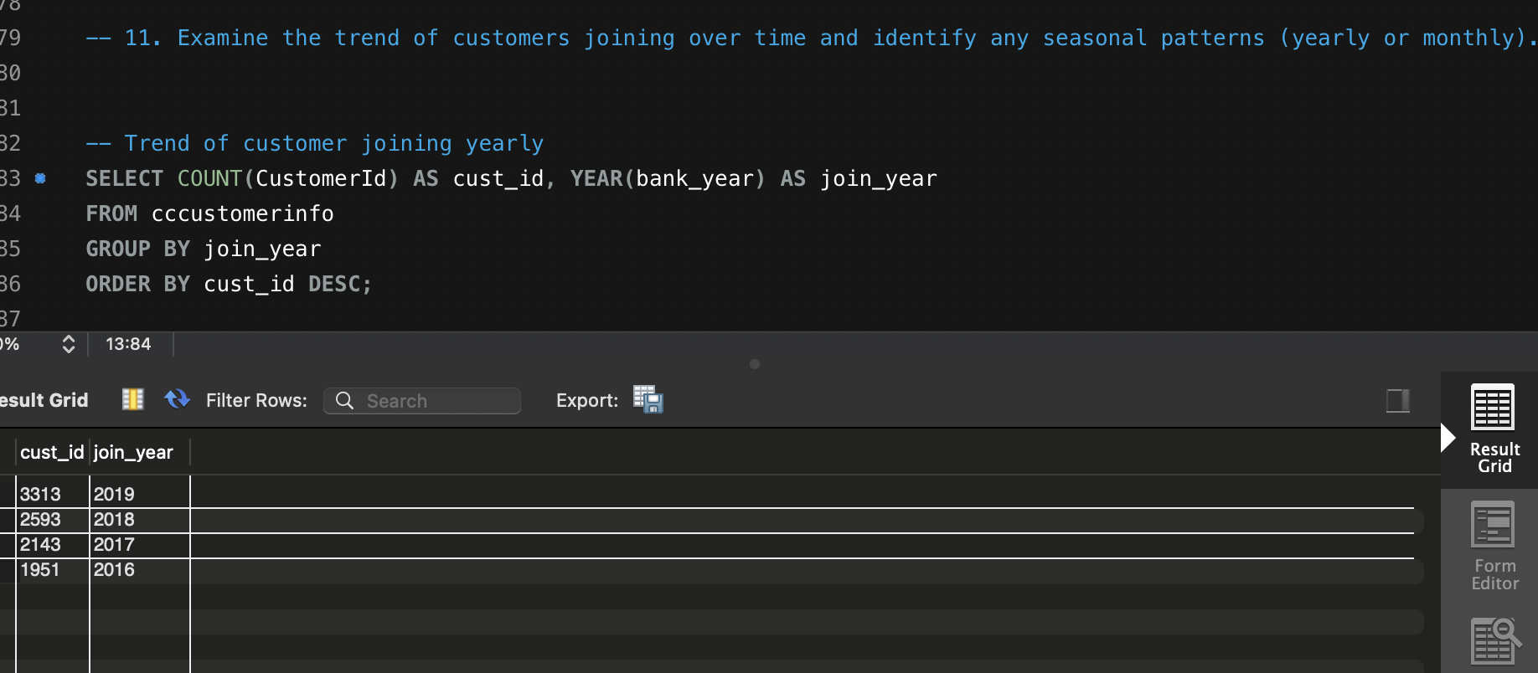

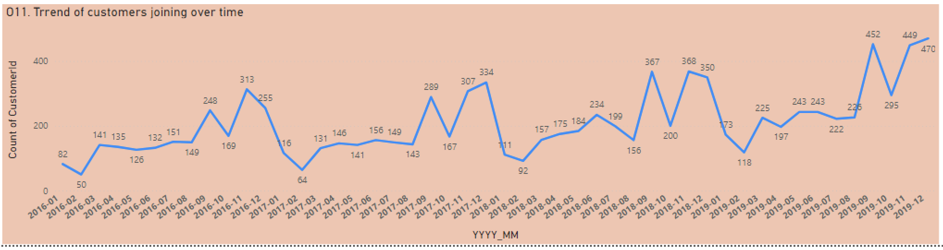

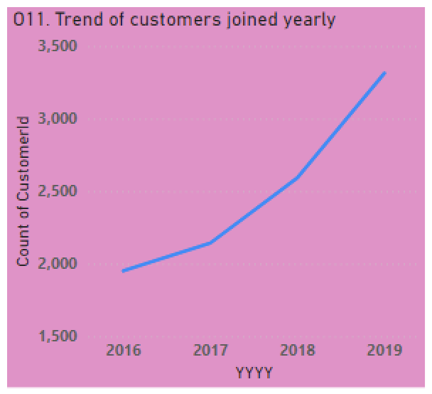

Ans:--) Insights:- Data shows that number of customers joining over the year has been rapidly increasing from year 2016 to year 2019.

Recommendations:- This shows a very good sign of growth and progress for the bank . Though if we see it in more detail over yearly monthly basis , we will see that counts of customers shows a zig - zag pattern.

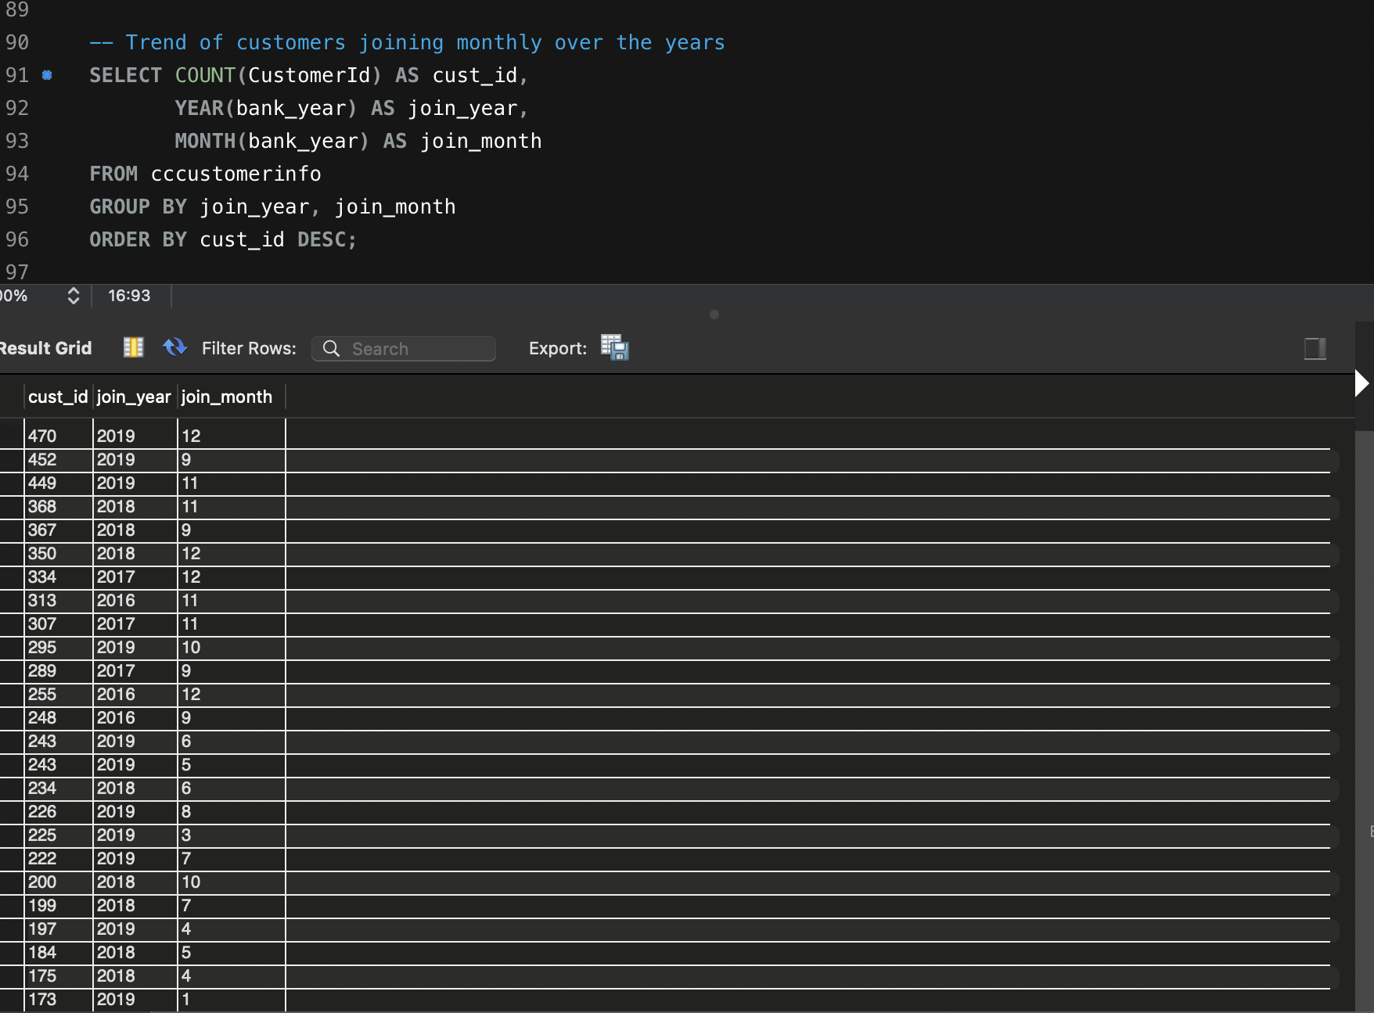

And we can see that trends of customers joining over monthly and yearly is significantly increasing that shows a good growth of the company.

12.) Analyze the relationship between the number of products and the account balance for customers who have exited.

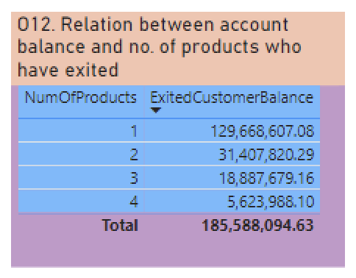

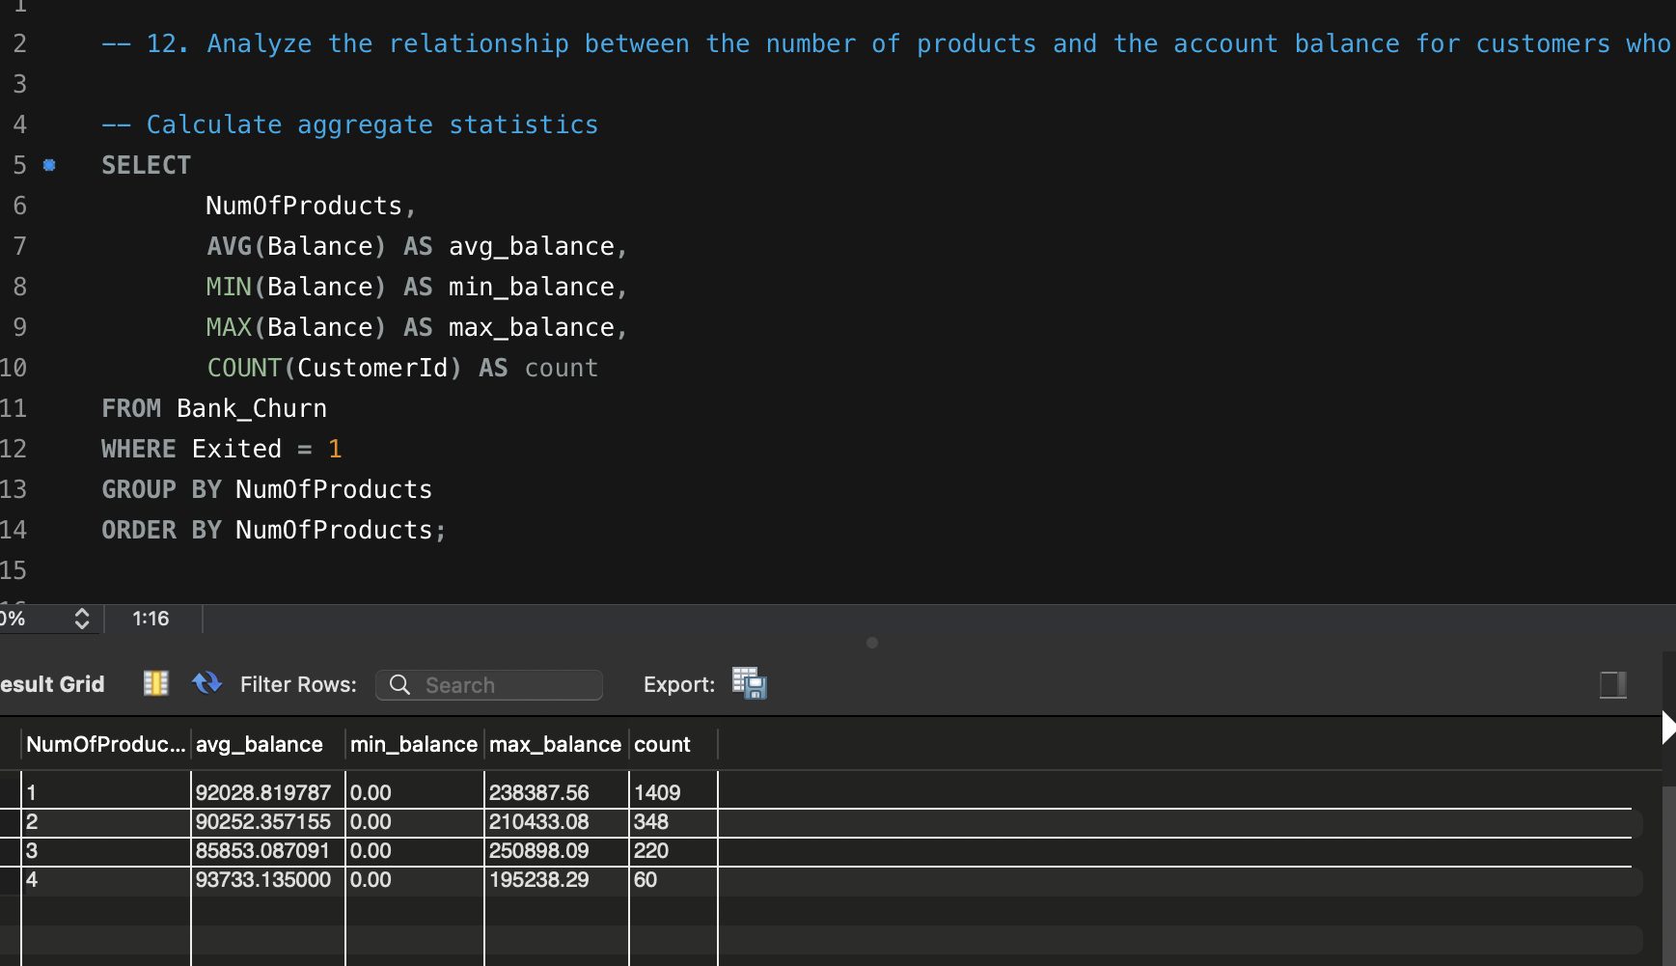

Ans:-) Data shows that customers using 4 number of products have highest average balance, and customers using 3 number of products has minimum average balance.

13.)Identify any potential outliers in terms of balance among customers who have remained with the bank.

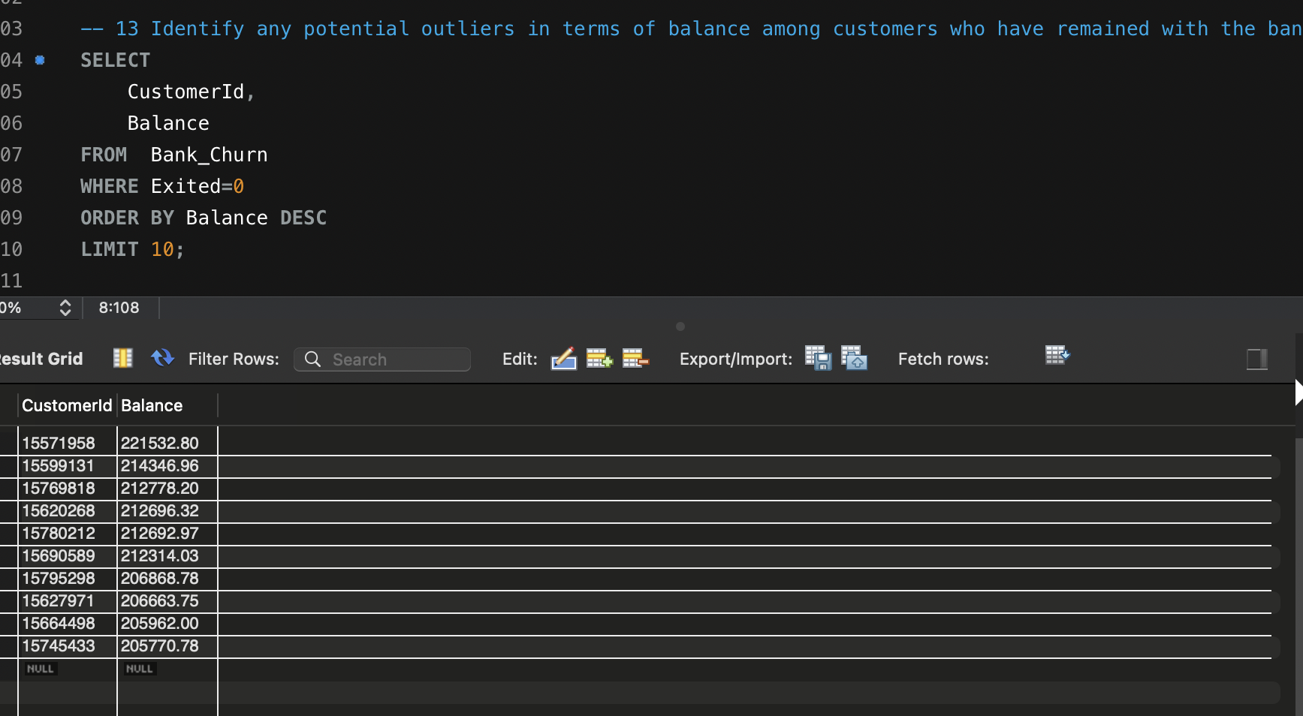

Ans:--) Above data shows that some customers have higher balance than majority of customers and thus are the potential outliers that remained with the bank.

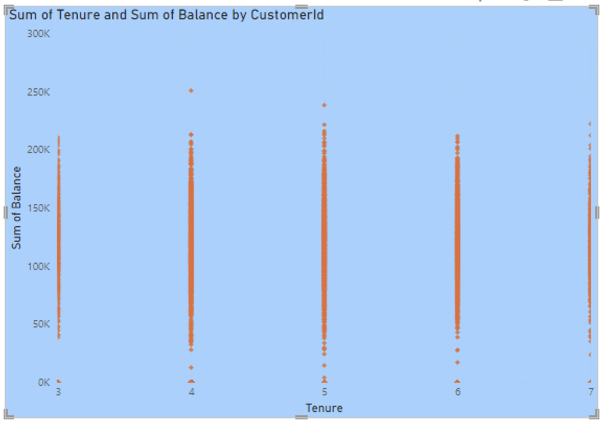

14.) How many different tables are given in the dataset, out of these tables which table only consists of categorical variables?

Ans:- 7 Different Tables are given . out of these tables 5 Tables consist of categorical variables only. These are Gender, ExitCustomer, CreditCard, Active Customers.

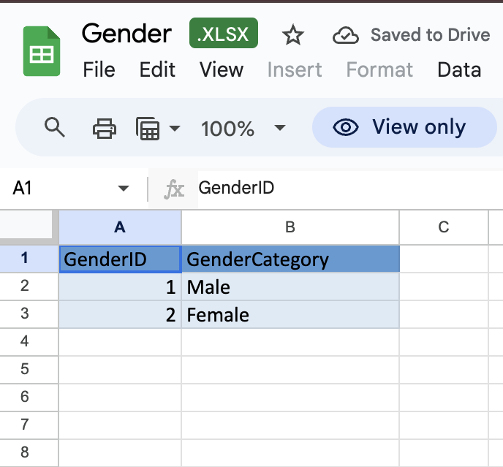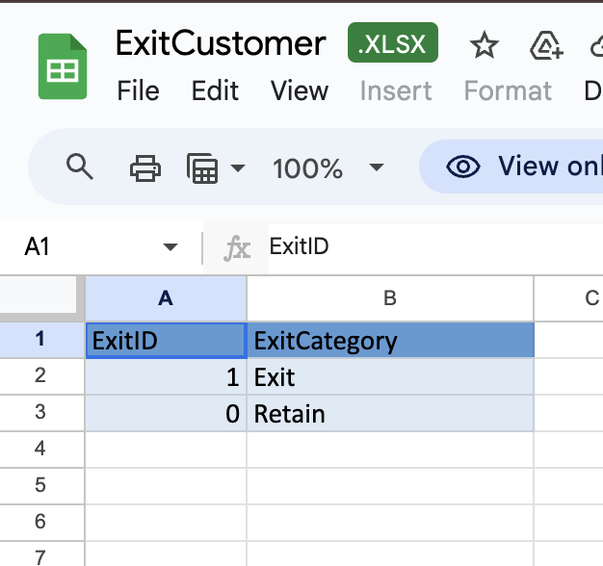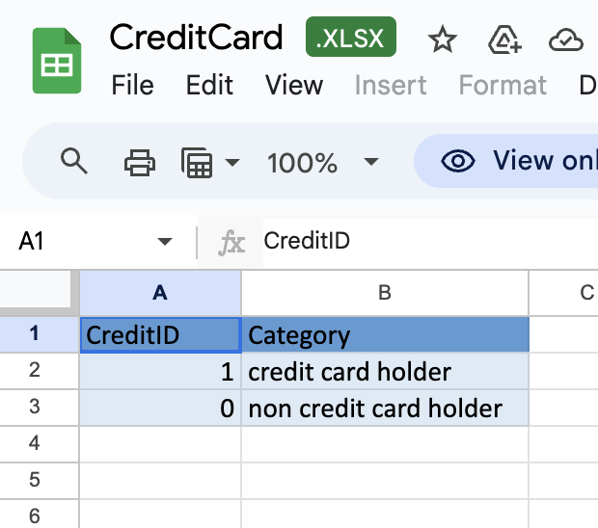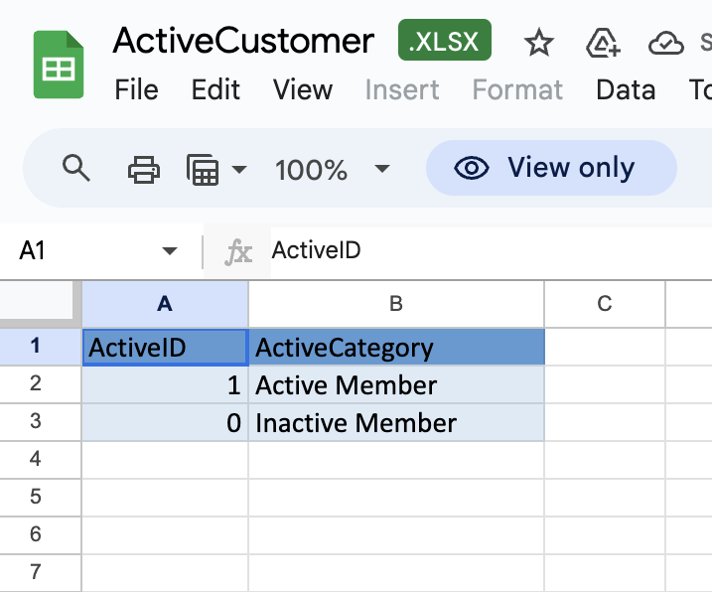

15.) Using SQL, write a query to find out the gender-wise average income of males and females in each geography id. Also, rank the gender according to the average value. (SQL)

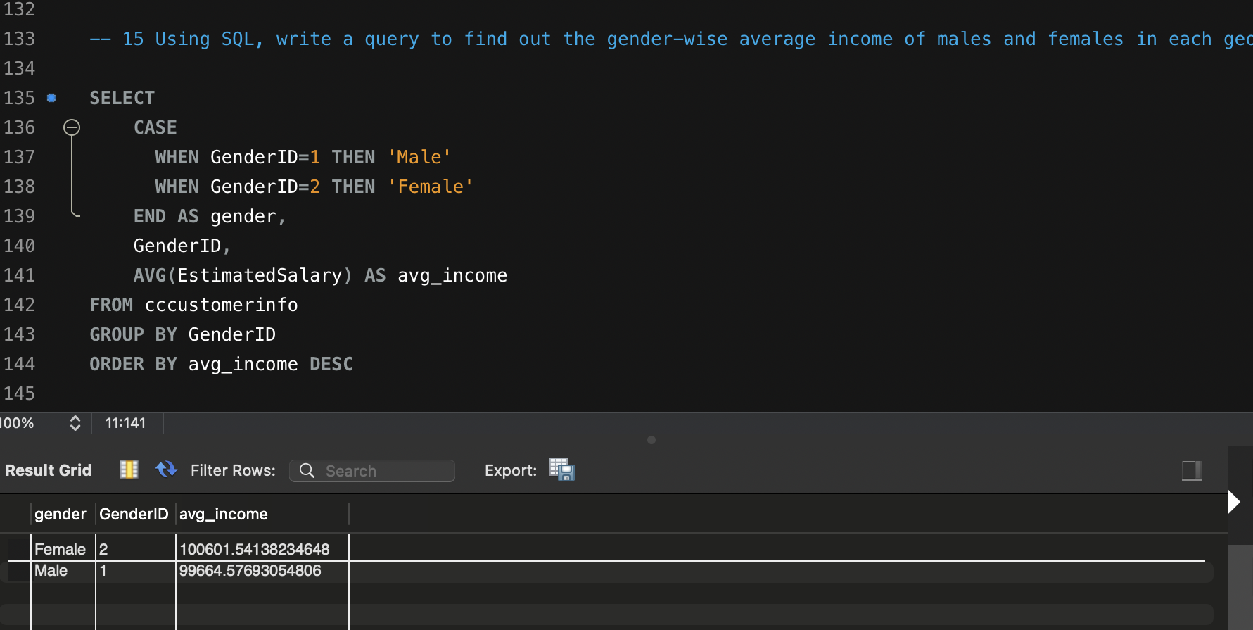

Ans:--) Insights:- Above Data shows that Female has the highest average income i.e 100601.541, then Males i.e 99664.5769

16.) Using SQL, write a query to find out the average tenure of the people who have exited in each age bracket (18-30, 30-50, 50+).

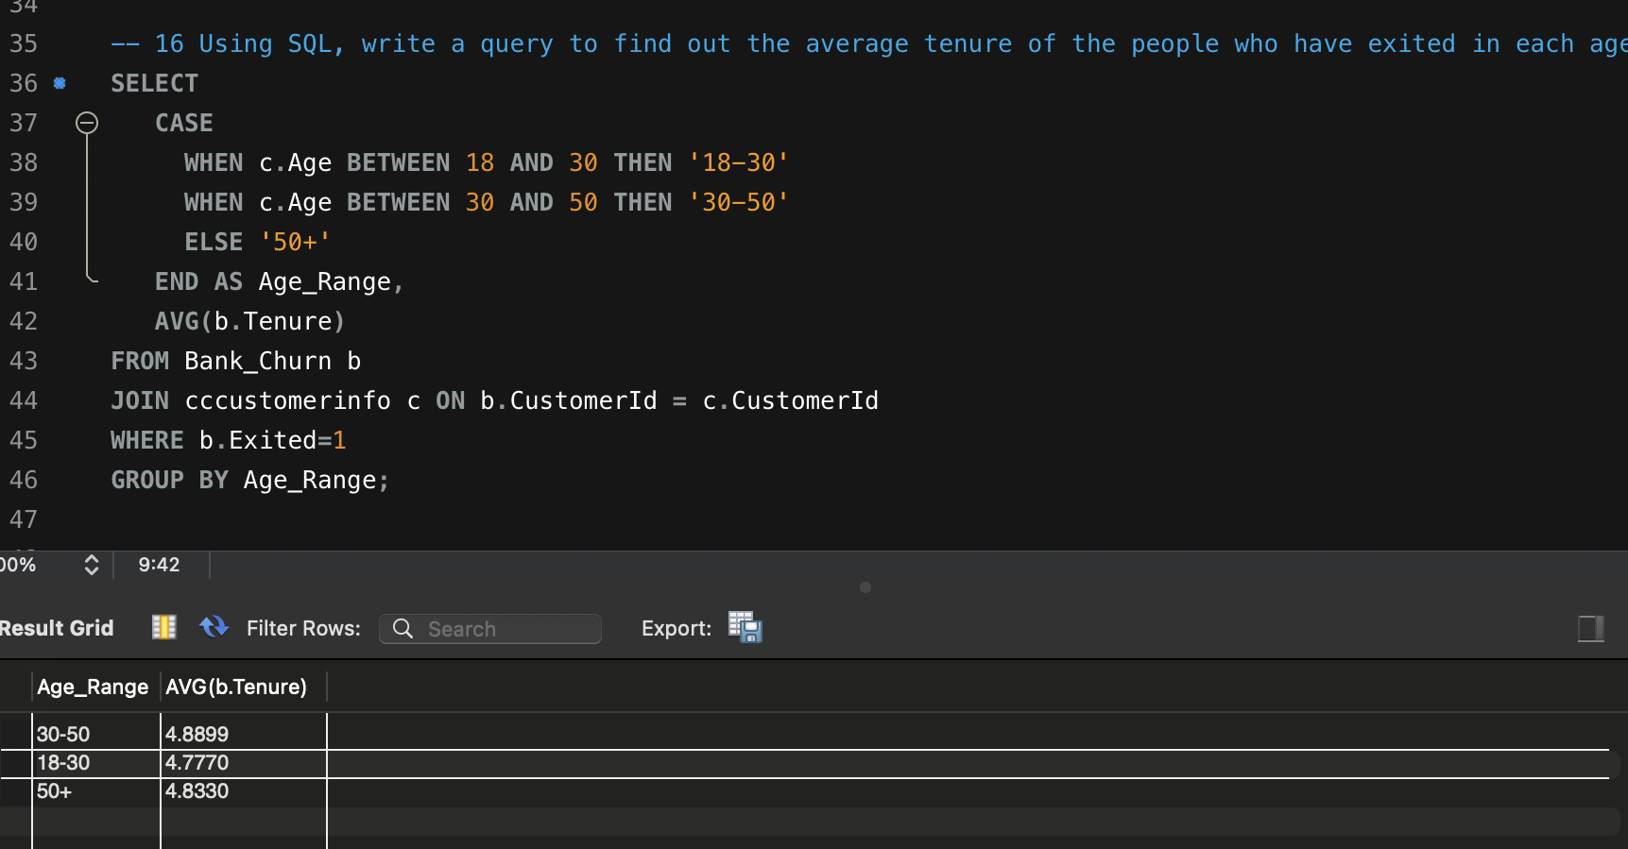

Ans:--) From the above data we can see that average tenure is highest for customers in age range of 30-50, then 50+ and then 18=30.

17.) Is there any direct correlation between salary and the balance of the customers? And is it different for people who have exited or not?

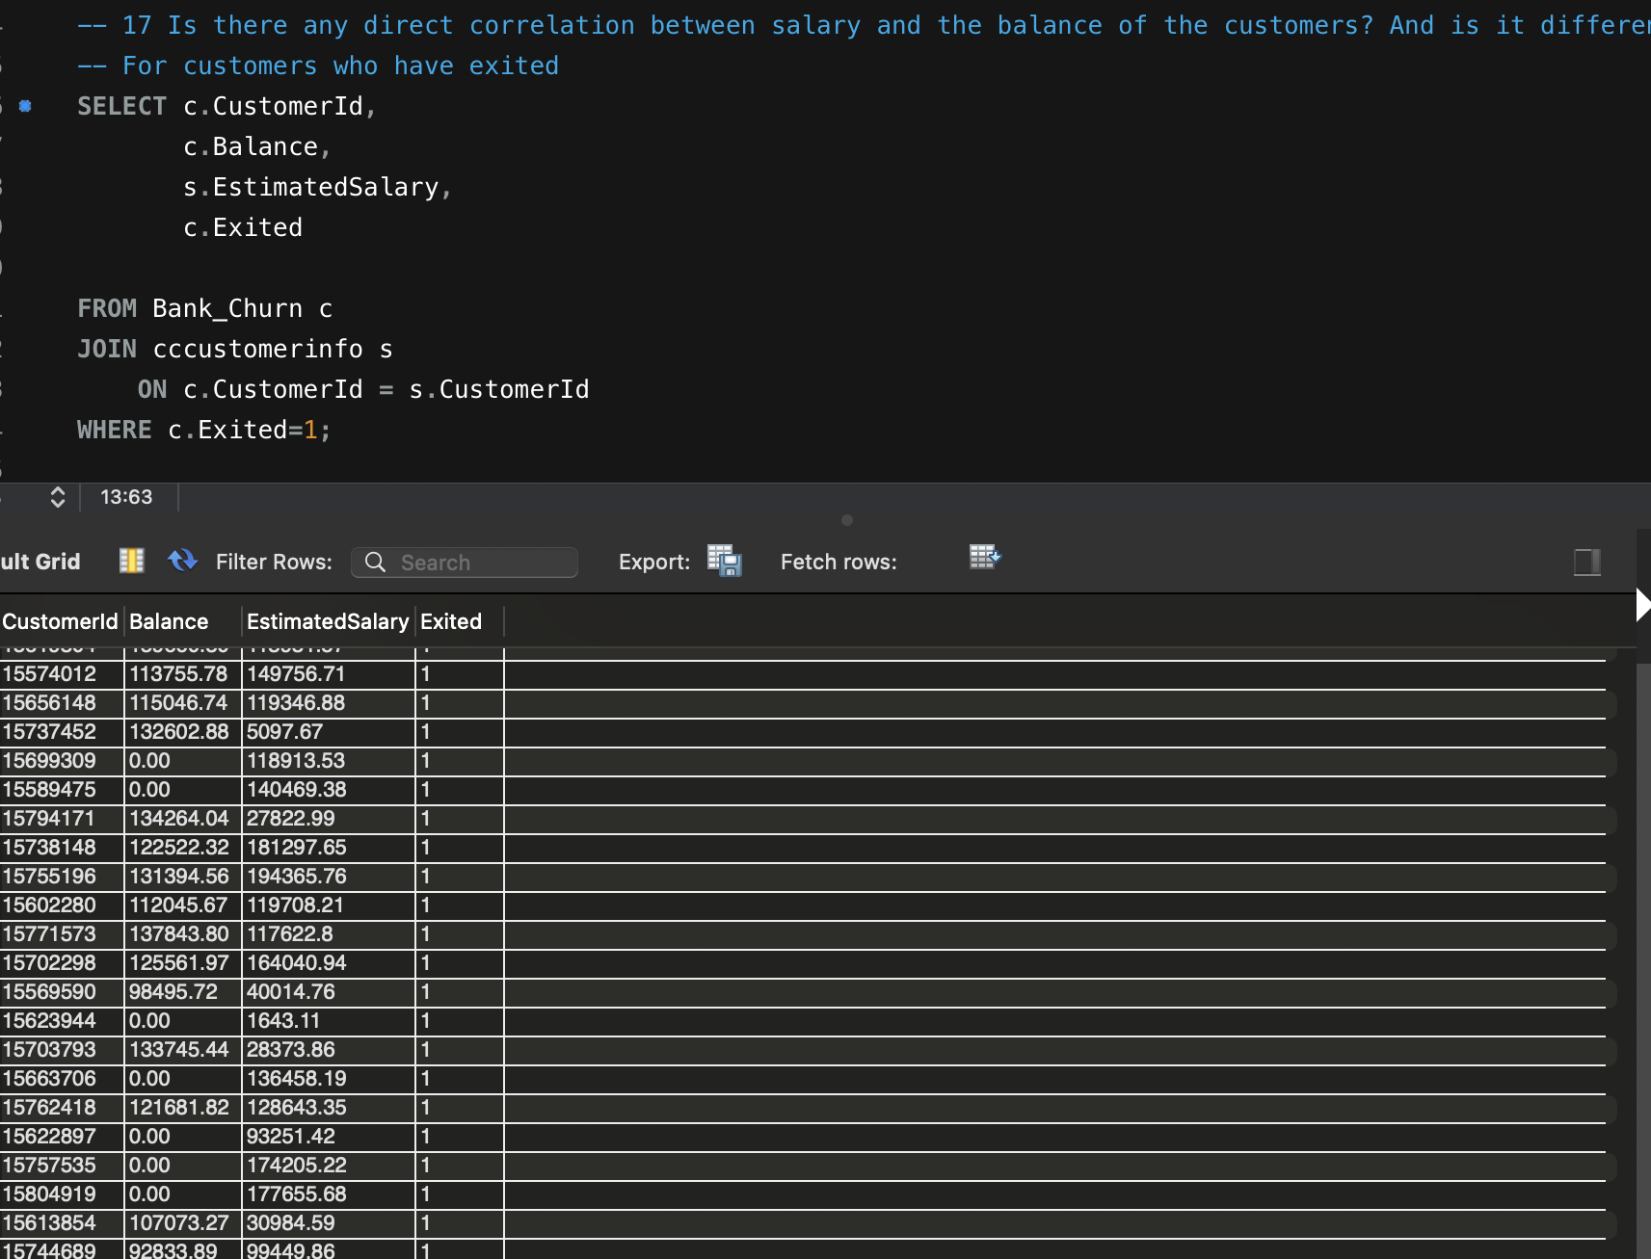

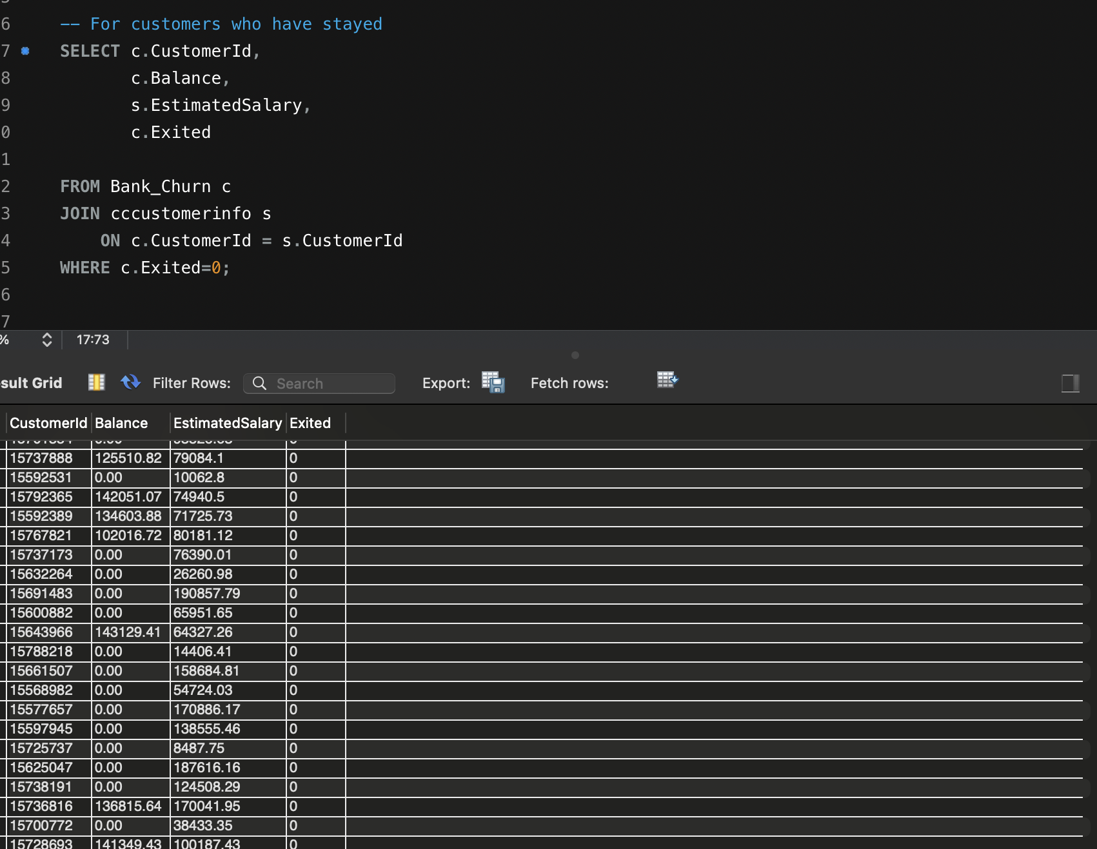

Ans:--) There seems to be no direct correlation between salary and the balance of the customers for both the customers who have exited and who have stayed.

18.) Is there any correlation between the salary and the Credit score of customers?

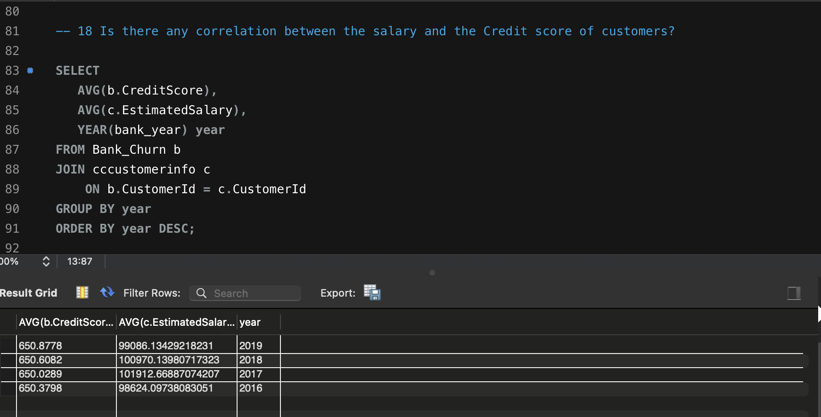

The average estimated salary of all the customers is same and also the average credit score of customers. Data don’t show any significant correlation between salary and credit score of customers.

19.) Rank each bucket of credit score as per the number of customers who have churned the bank.

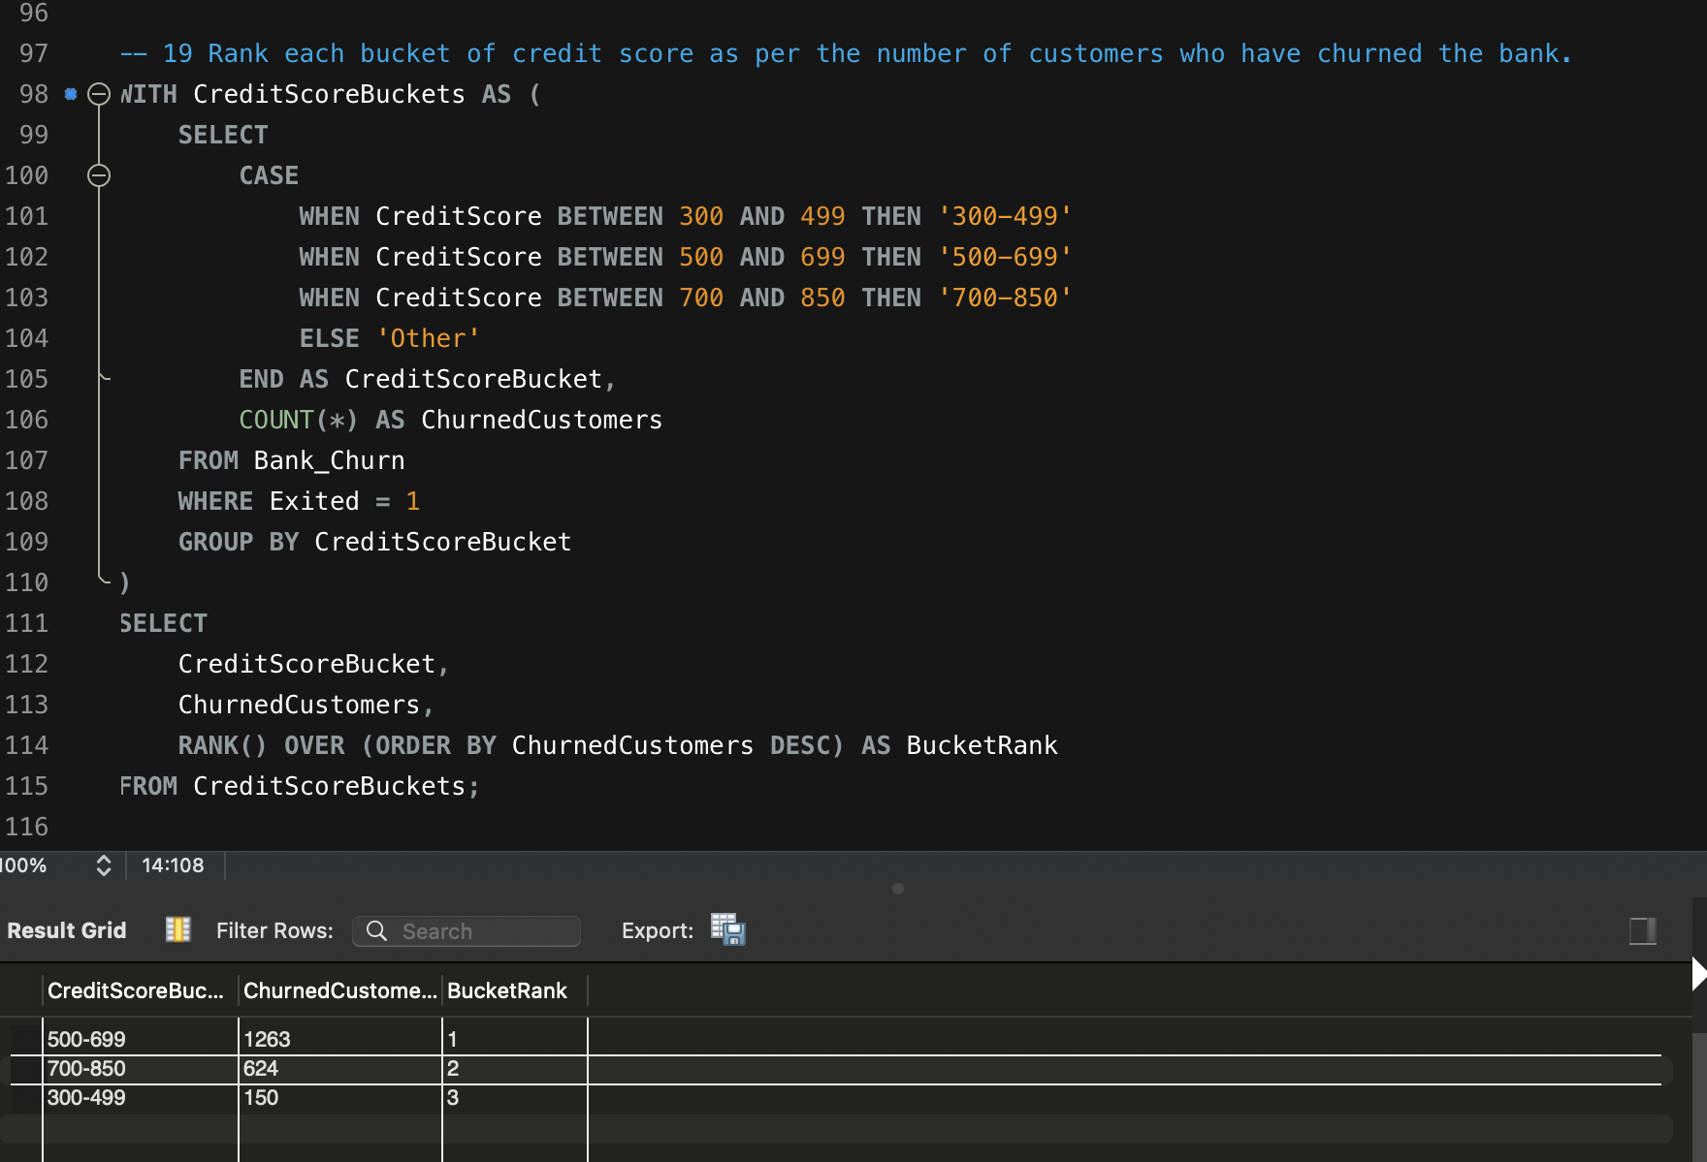

Ans:--) As we can see from the data that the customers having the credit score in range of 500-699 tend to show highest number of customer churn as compare to other ranges.

20.) According to the age buckets find the number of customers who have a credit card. Also retrieve those buckets that have lesser than average number of credit cards per bucket.

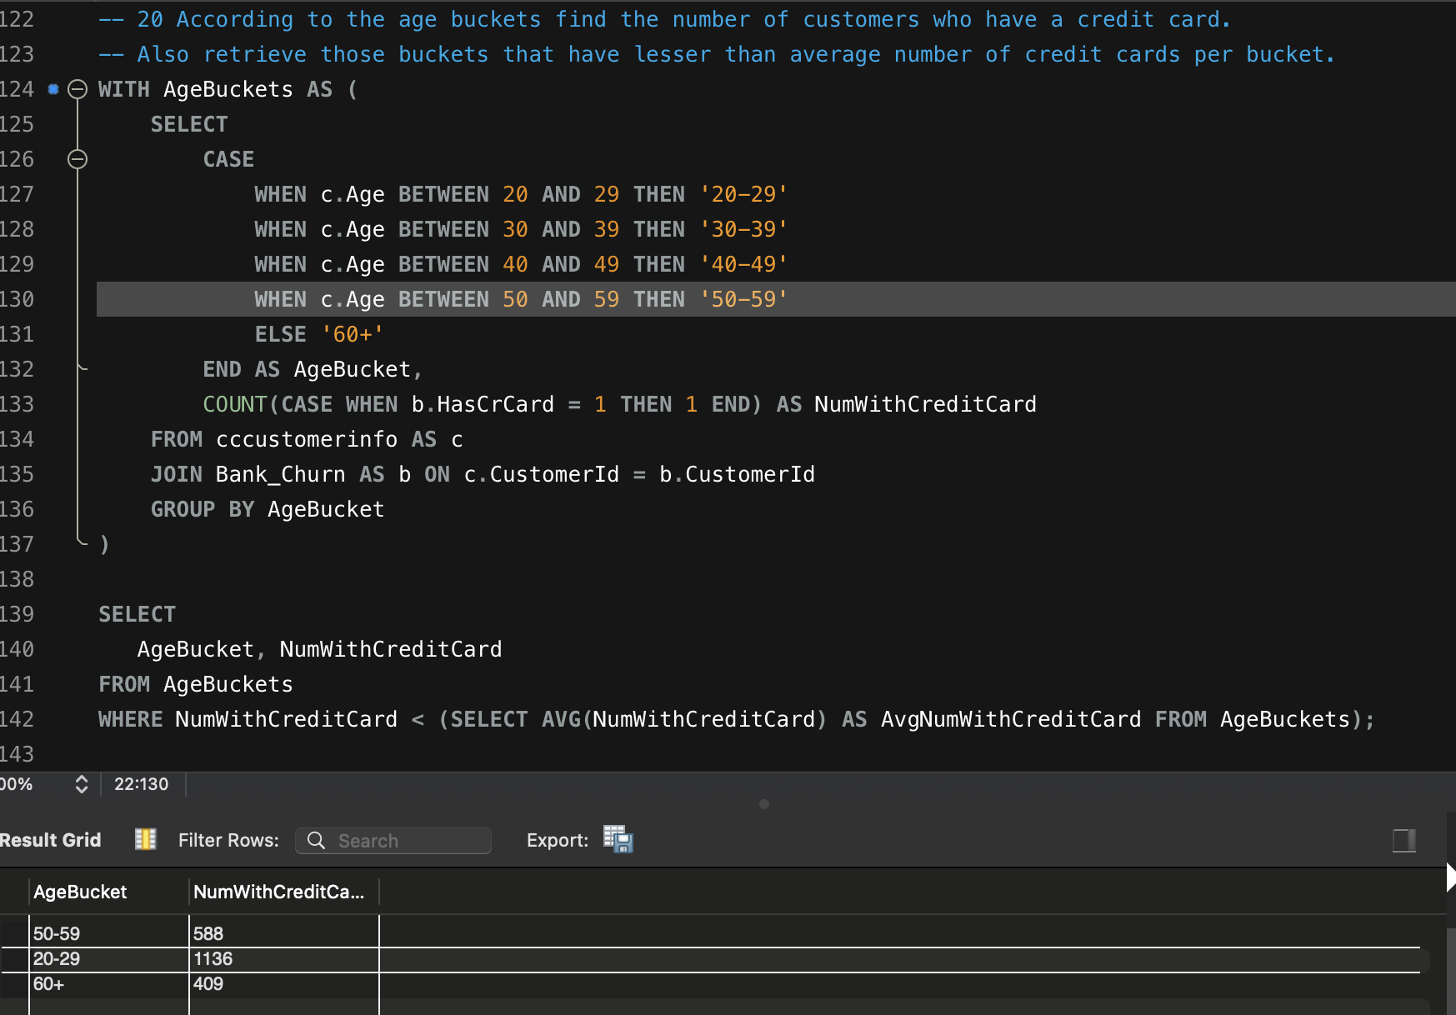

The above data shows that customers in the age range of 20-29 tend to show highest number of customers who have less than average number of credit cards.

21.) Rank the Locations as per the number of people who have churned the bank and average balance of the customers.

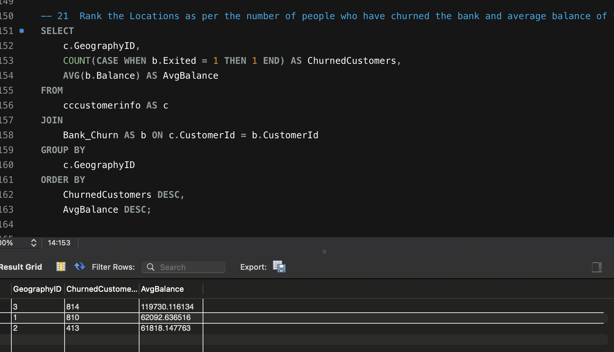

Ans:--) Data shows that from Geography ID 3 , there is a maximum number of customer churn and the average balance . Though customer churn doesn't seem to show any justifiable reason with the average balance of customers.

22.) As we can see that the “CustomerInfo” table has the CustomerID and Surname, now if we have to join it with a table where the primary key is also a combination of CustomerID and Surname, come up with a column where the format is “CustomerID_Surname”.

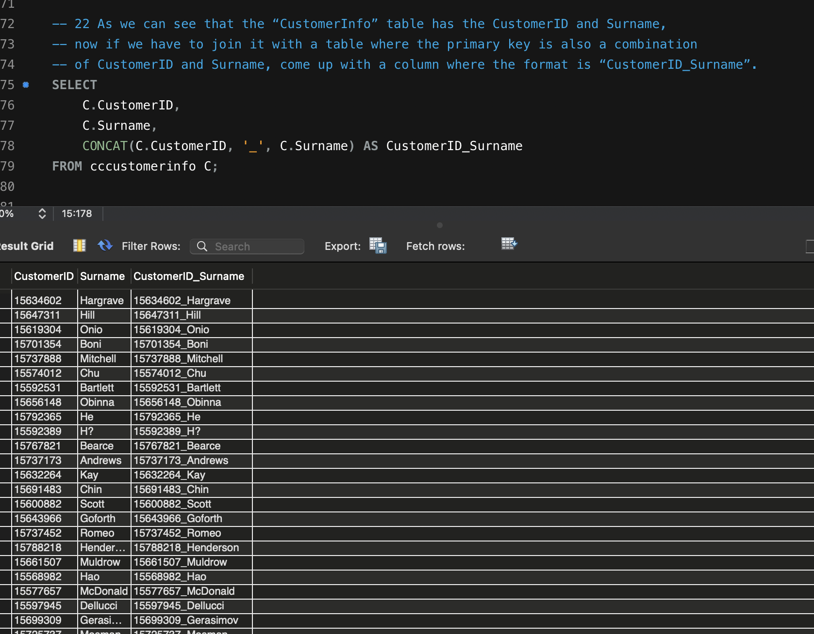

Ans:-) The above data show the combined customer id and surname in column CustomerID_Surname is joined using a CONCAT keyword in sql.

23.) Without using “Join”, can we get the “ExitCategory” from ExitCustomers table to Bank_Churn table? If yes do this using SQL.

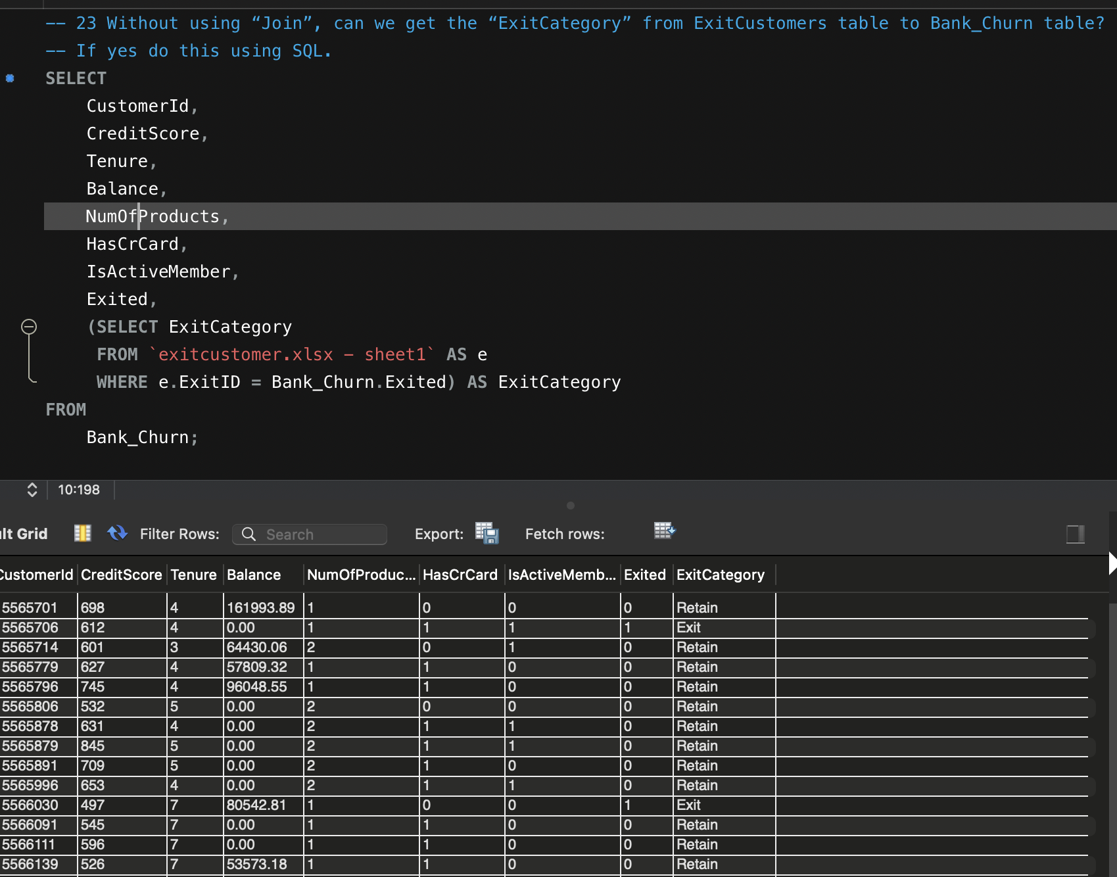

24.) Were there any missing values in the data, using which tool did you replace them and what are the ways to handle them?

Ans.) No, there was no missing value. If there would have missing value i would have either removed that null value or replaced the missing value with the Mean, Median or Mode as per the use case.

25.) Write the query to get the customer IDs, their last name, and whether they are active or not for the customers whose surname ends with “on”.

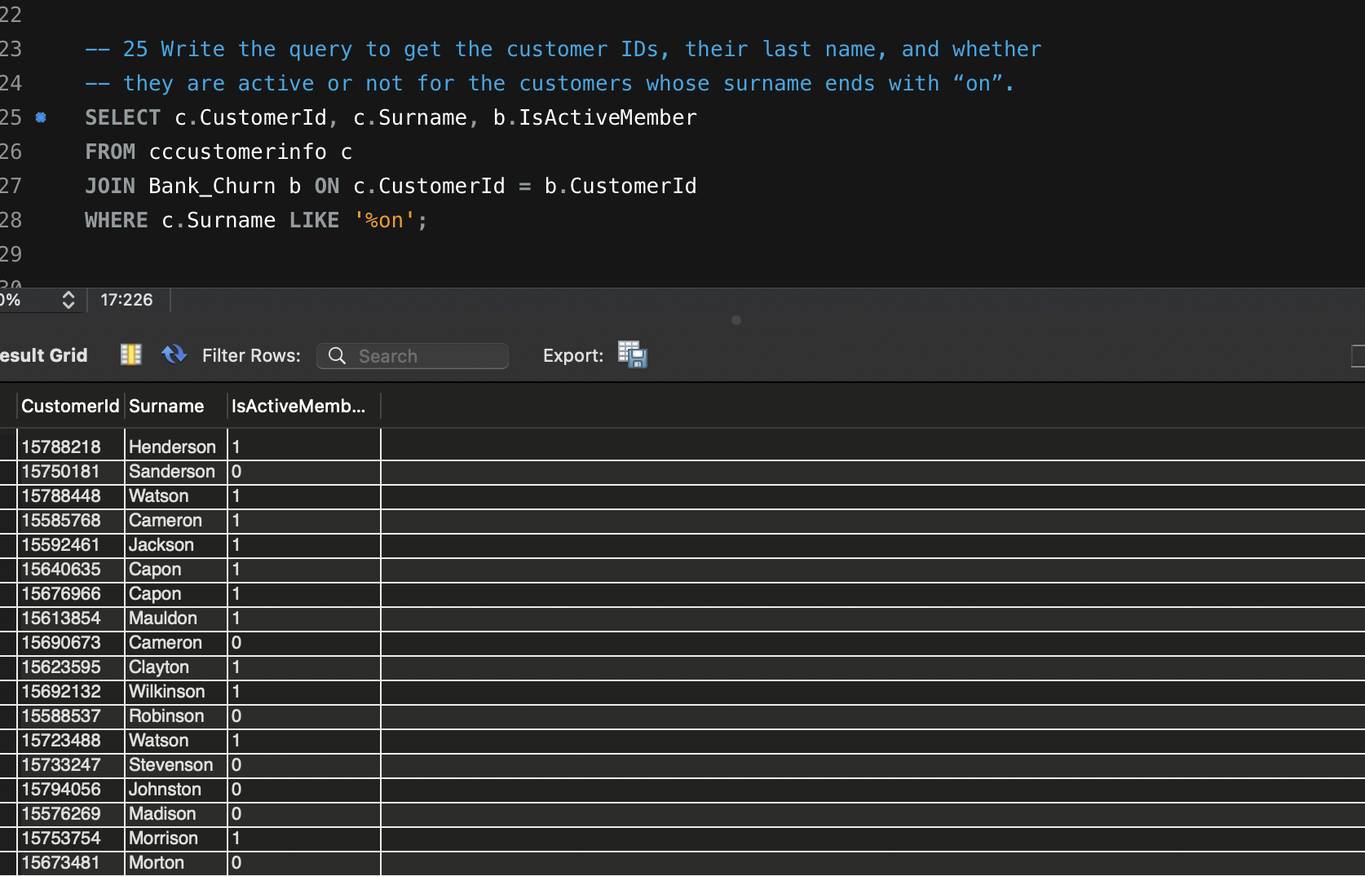

The above data shows the customer Id, their last name, and whether they are active or not and whose name ends with “on” using LIKE “%on” in mysql.

26.) Can you observe any data disruption in the Customer’s data? As a hint it’s present in the IsActiveMember and Exited columns. One more point to consider is that the data in the Exited Column is absolutely correct and accurate.

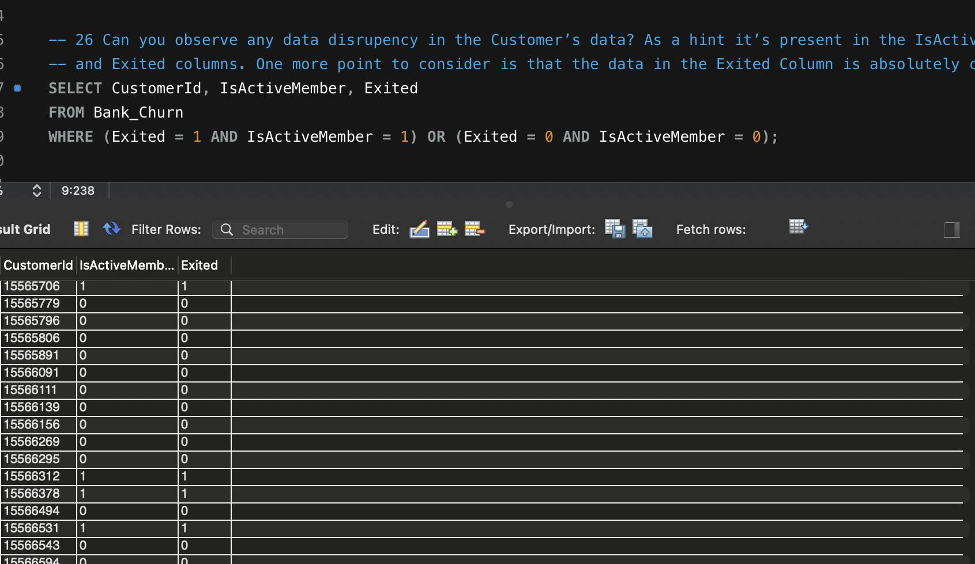

Insights;-No, i cannot see any discrepancy in Customer’s data.

**Subject SQL Questions:-**

1. **Customer Behavior Analysis: What patterns can be observed in the spending habits of long-term customers compared to new customers, and what might these patterns suggest about customer loyalty?**

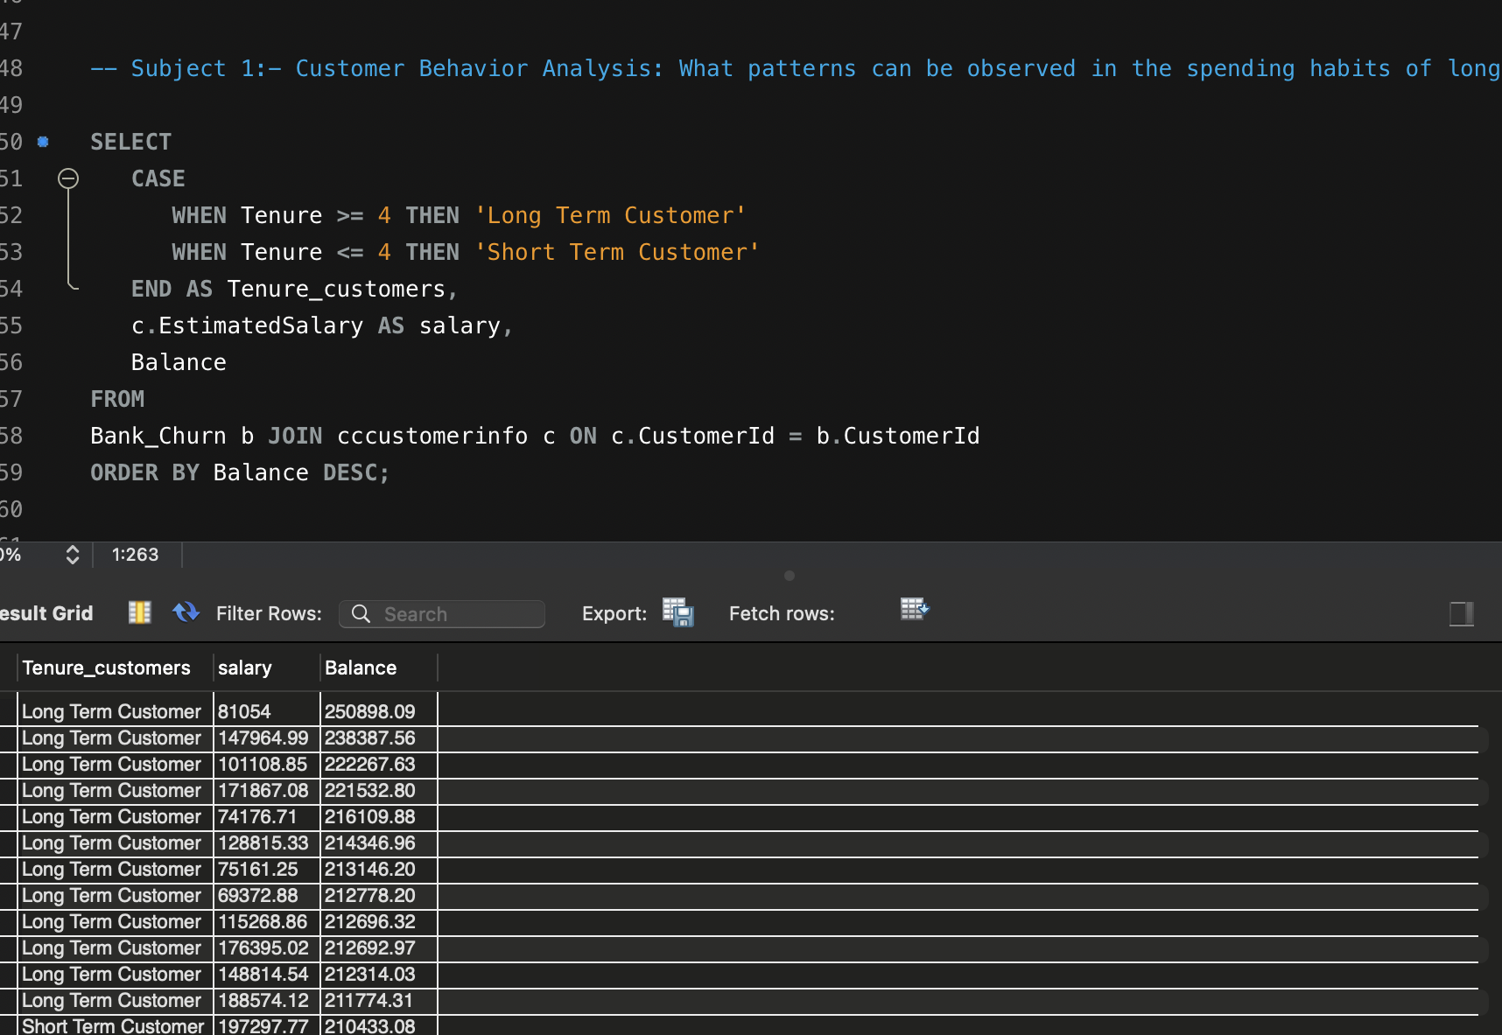

As we can clearly see from data that, spending habits of Long Term Customers are quite good, which suggests that these customers are quite loyal to the bank and have quite big amount of money in terms of balance in the account as compared to Short Term Customers.

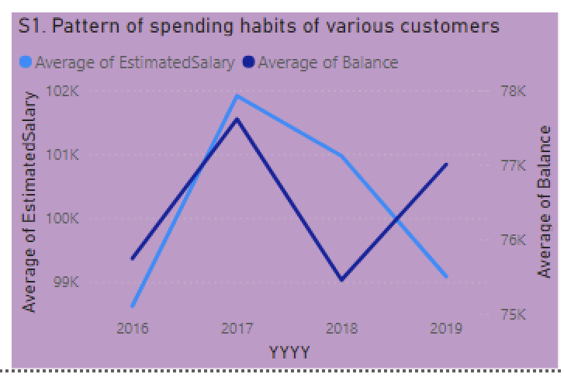

**2.) Product Affinity Study: Which bank products or services are most commonly used together, and how might this influence cross-selling strategies?**

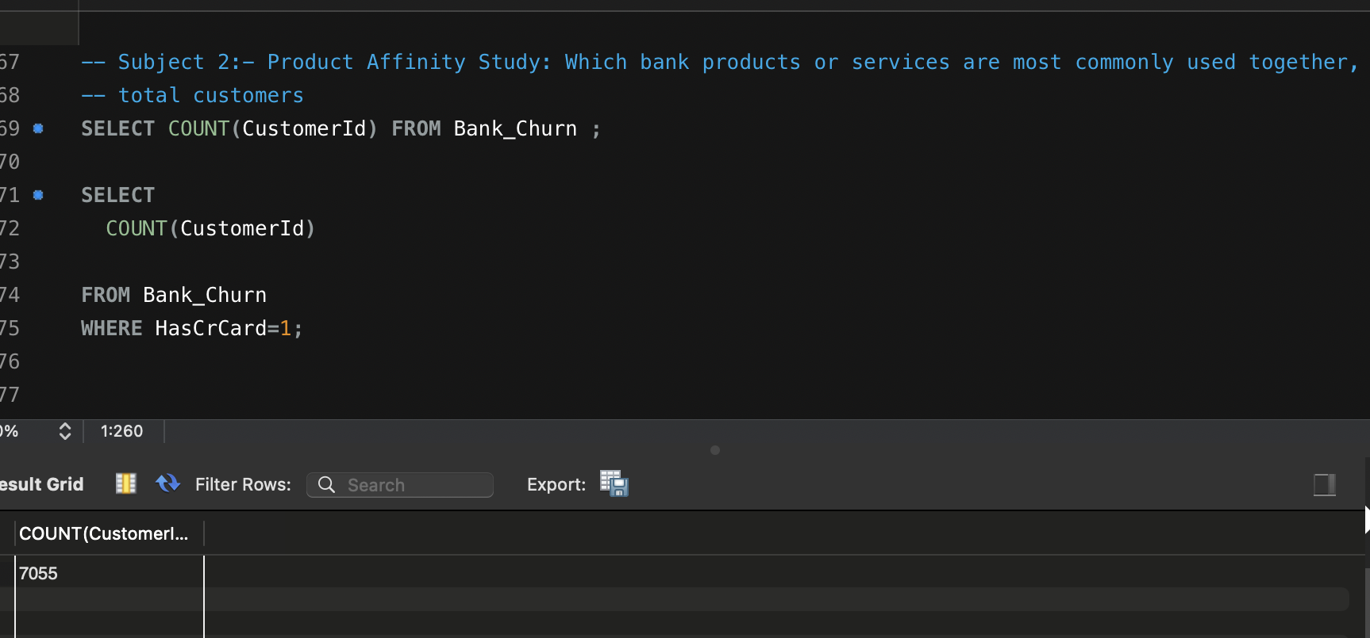

1. As we can clearly see from data that credit card facility is most commonly used by the customers. As out of total 10000 customers 7055 customers are using credit card.
2. As in the data only credit card service is given so, based on this only we made a analysis of how credit card service is used for customer retention and involvement. This is one of the strategy used by the bank to reduce the churn rate and increase customers loyalty.
3. The main reason behind credit card plays a pivotal role in customer retention as customers also gets to spend whenever they need and on top of that they are also rewarded from bank for using customer card .

**3.) Geographic Market Trends: How do economic indicators in different geographic regions correlate with the number of active accounts and customer churn rates?**

**Ans:) Insights:-** As we can clearly see from data below that economic conditions do not have much or any impact on customer churn for active customers . the above data clearly justifies it by providing a comparative analysis for customers who have churned and for customers who are still with the bank.

**Recommendations:-** In order to reduce customer churn bank can offer various services such as credit card facility, bank loan, home loan , education loan, low interest on various loans and high interest on saving account of customers.

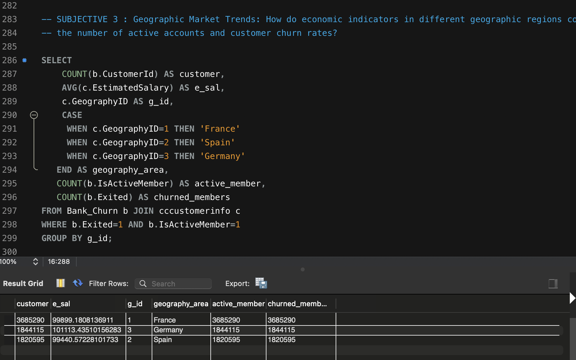

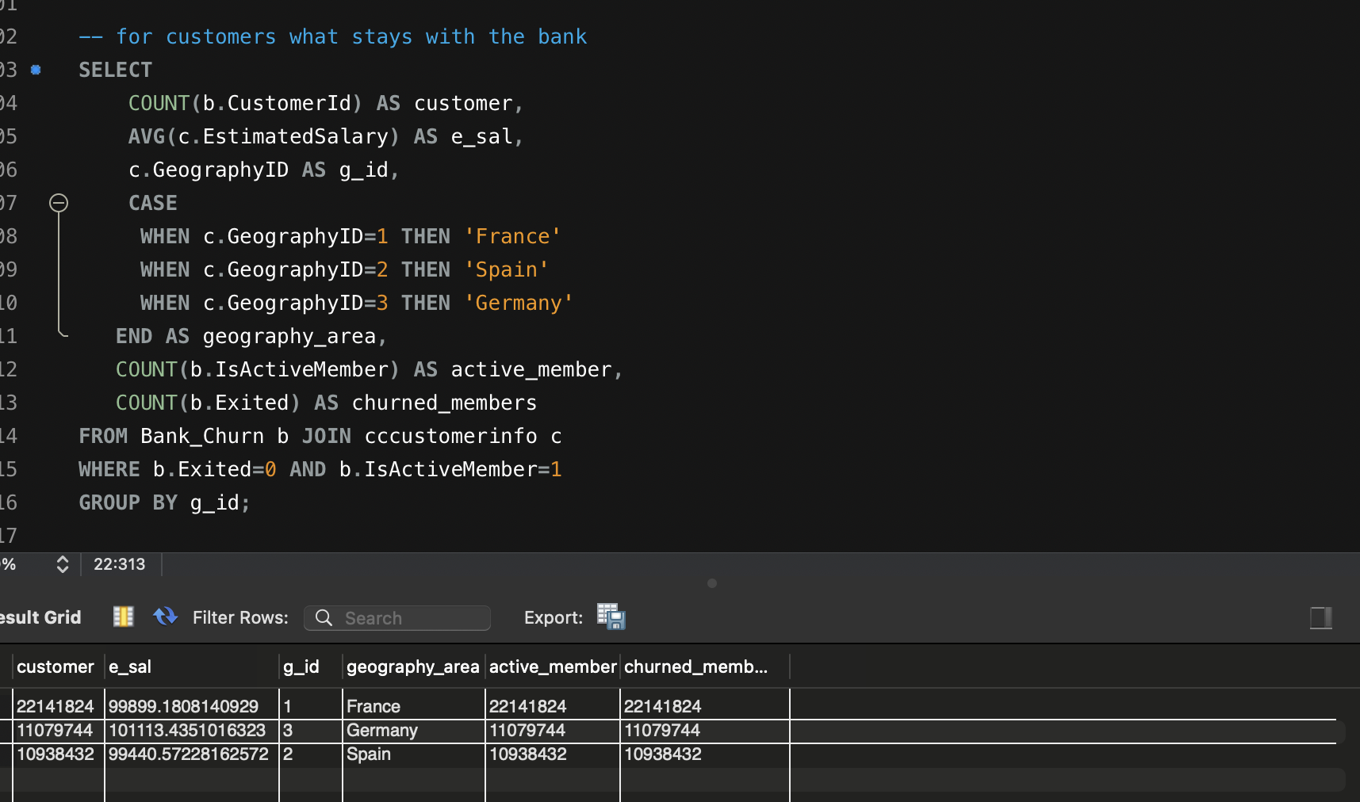

**4.) Risk Management Assessment: Based on customer profiles, which demographic segments appear to pose the highest financial risk to the bank, and why?**

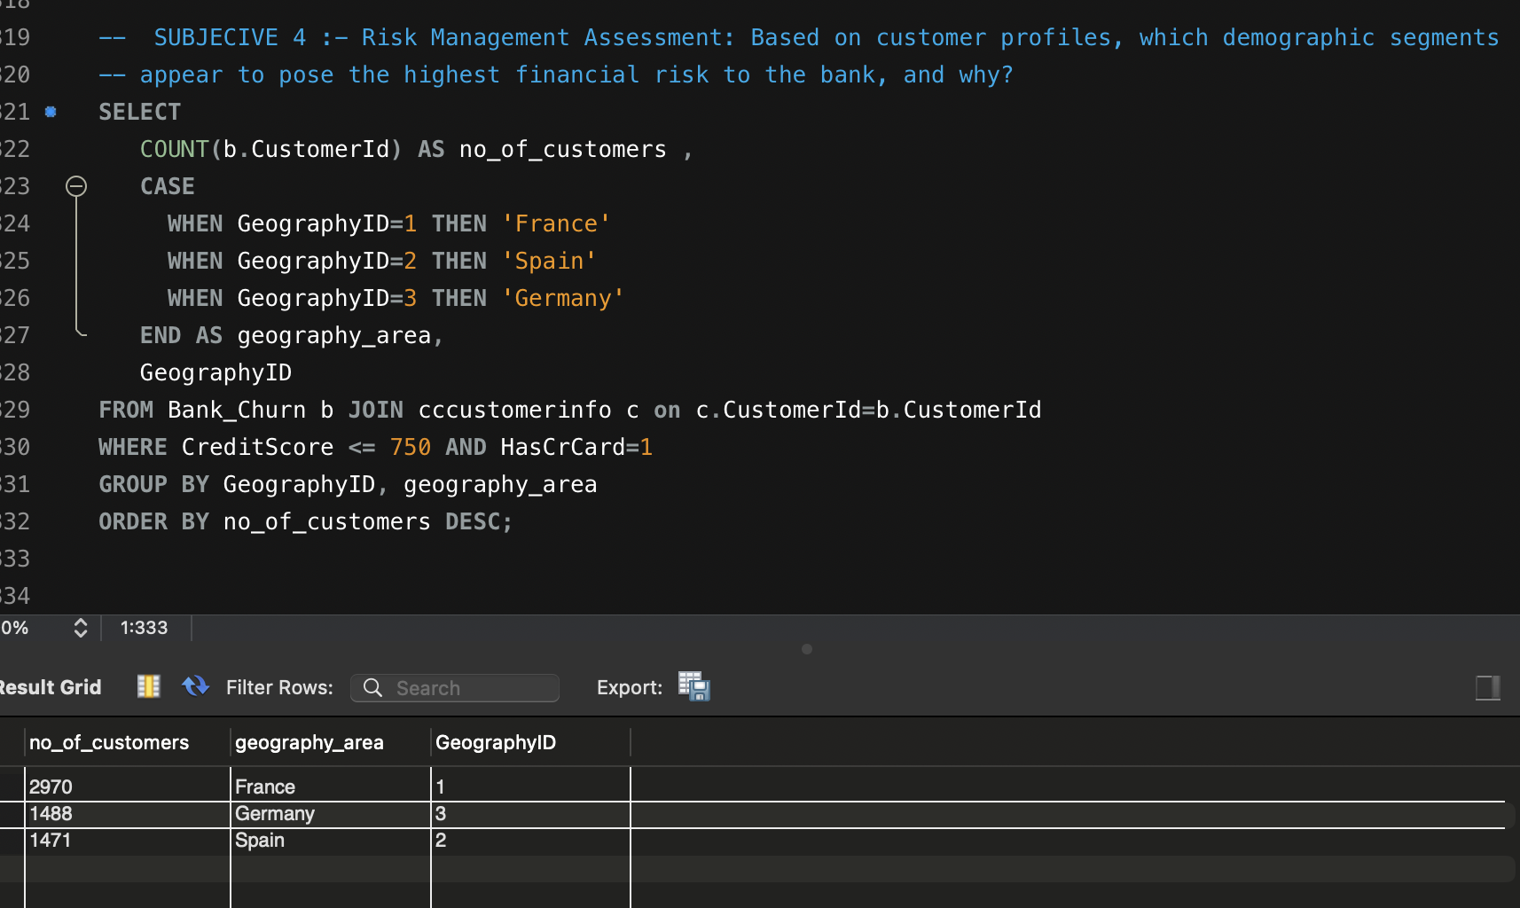

Insights:As we can clearly see from that France appear to pose the highest financial risk to the bank as the number of customers who have credit score below 750 is largest in france. which signifies that after taking loan from the bank customers in France region have the largest number of people who are unable to repay the loan amount back to the bank,thus posing highest risk.

Recommendations:- From the sql data and visualization it is clear that customers in geography id 1 poses highest financial risk to the bank as average credit card score of customers in that region is very less. So if bank want to be on safe side bank can give credit card to selected number of people to customers who have very good cibil score or credit card score and while providing loan to customers bank should extensively do background check of finance of customers and perform analysis whether it is safe for bank to give loan or credit card to certain customers.

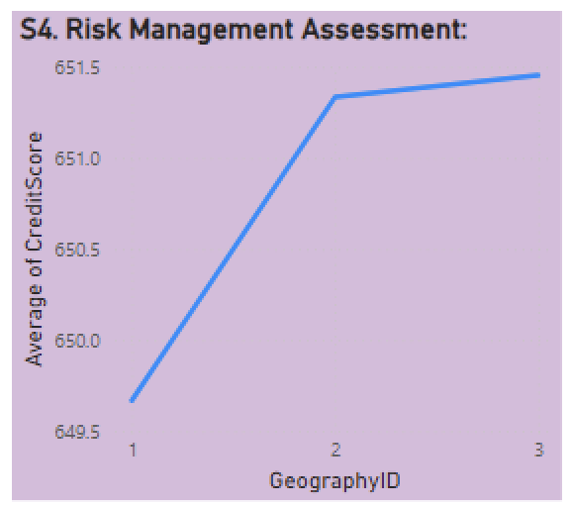

**5.) Customer Tenure Value Forecast: How would you use the available data to model and predict the lifetime (tenure) value in the bank of different customer segments?**

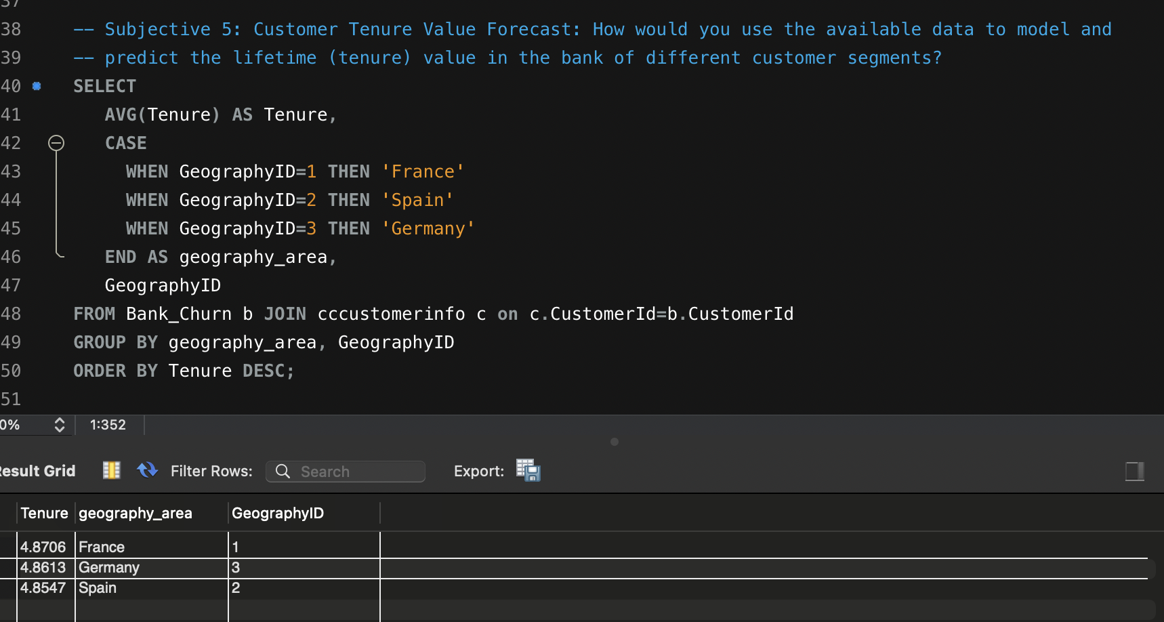

Insights:- As we can clearly see from the data customers from all the regions France, Germany, and Spain have almost the same tenure which revolves around 4.8 or 4.7 years.

Recommendations;-

**6.) Marketing Campaign Effectiveness: How could you assess the impact of marketing campaigns on customer retention and acquisition within the dataset? What extra information would you need to solve this?**

Ans.) As i can see from data, there is no data given for Marketing campaign.

**-Additional Data Needed:**

1. Marketing Campaign Information:
2. Date of campaign launches and details on which customers were targeted.

3.) Type of campaigns (e.g., email, discounts, product offers).

4.) Customer Interaction Data:

5.) When a customer interacted with a campaign (if they did).

6.) Behavioral metrics like product purchases post-campaign or engagement with marketing materials.

7.) New Customer Data:

8.)Information on when a customer was acquired (could use Bank DOJ, but more precise campaign-related data would help).

**7.)Customer Exit Reasons Exploration: Can you identify common characteristics or trends among customers who have exited that could explain their reasons for leaving?**

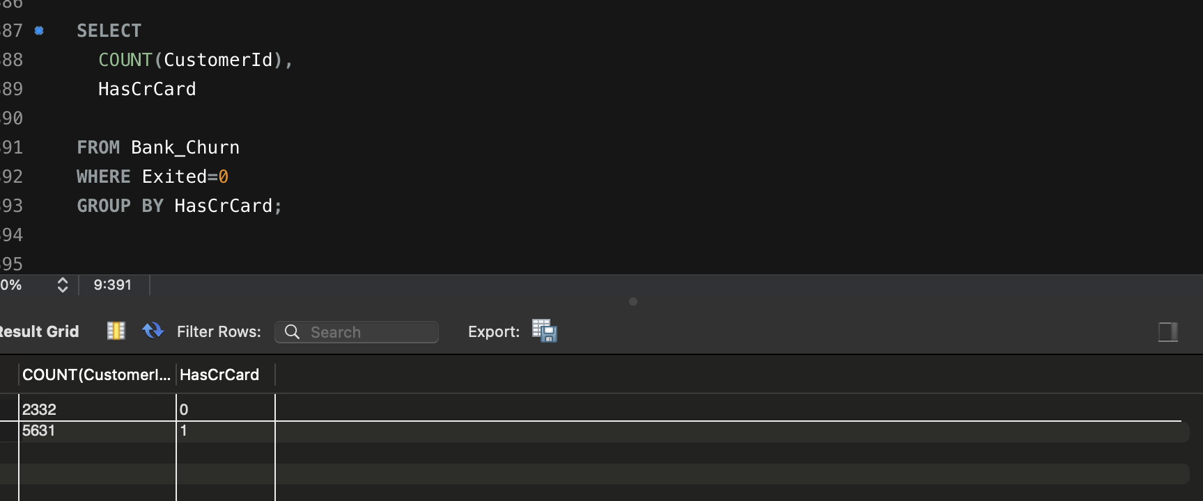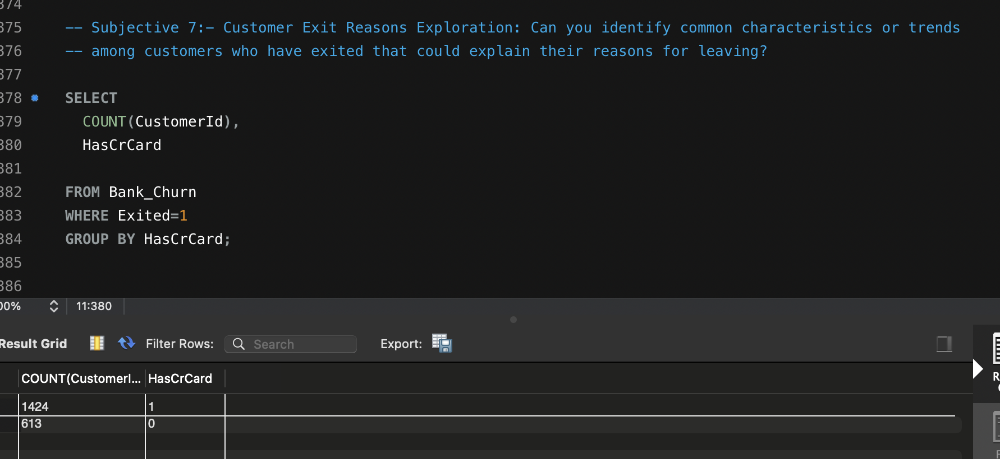

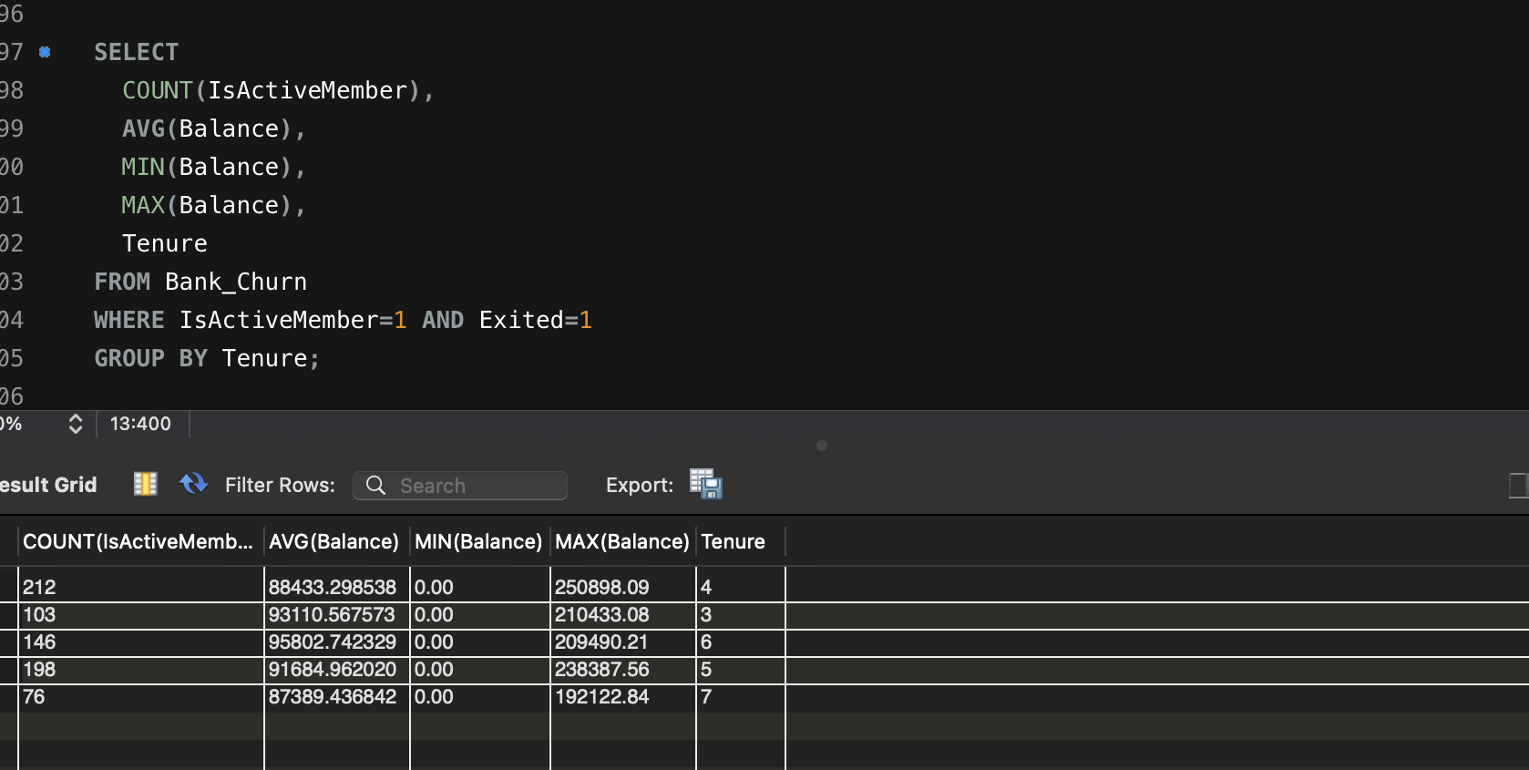

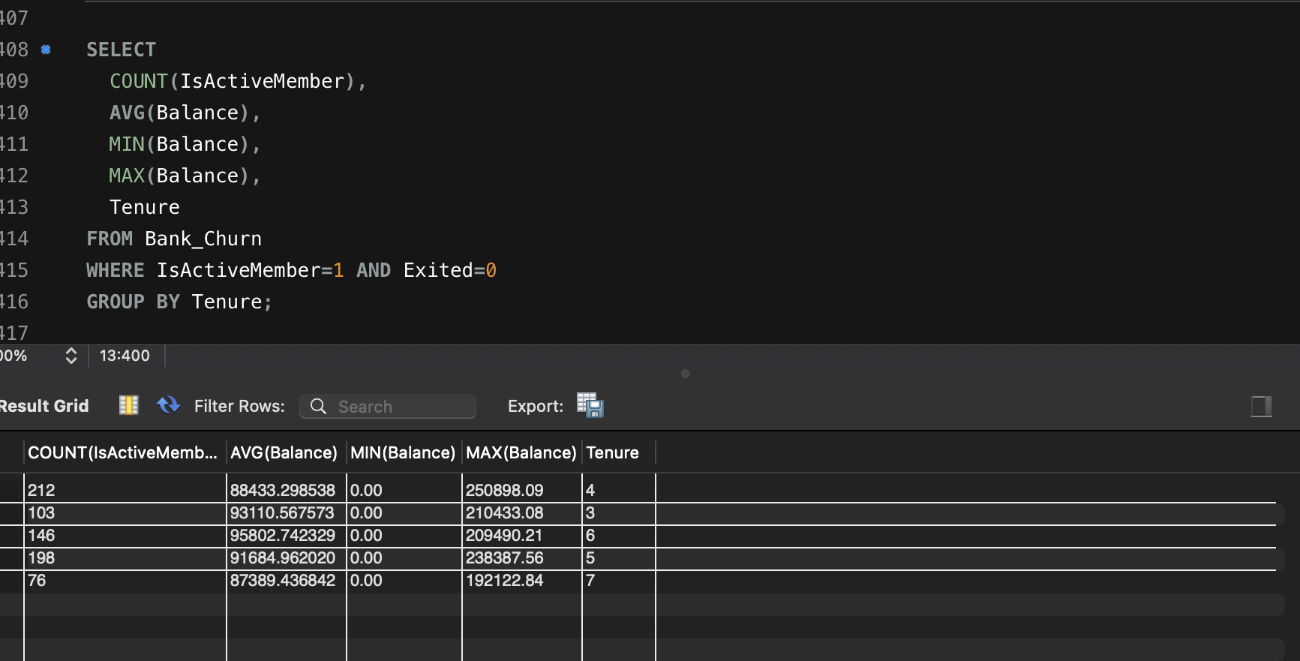

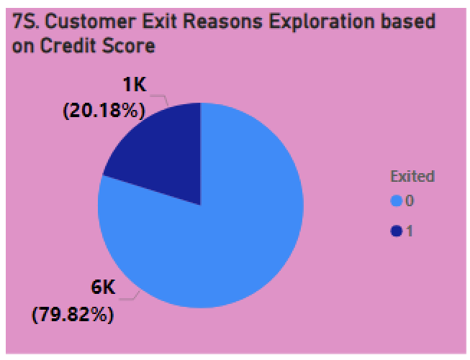1.)Insights:- By performing analysis we can see that customers who have credit card is likely to remain with the bank and customers who don’t have credit card is most likely churn from this visualization it is clearly visible.

2.) Recommendations:- So, if bank wants to reduce customer churn , bank should try to use credit card service and try to make this service available to every customers joining the bank . that will help reduce the churn rate

**8.)Are 'Tenure', 'NumOfProducts', 'IsActiveMember', and 'EstimatedSalary' important for predicting if a customer will leave the bank?**

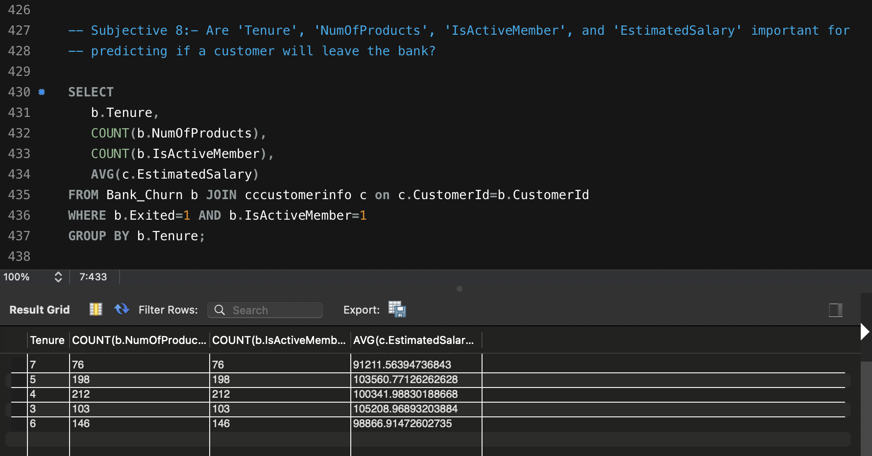

1. **As we can see from the data customers who have a tenure around 4 or 5 years tend be more active and have more churn rate as compared to long term customers who have a tenure around 7 or 8 years tenure. And estimated salary seem to have no impact on customer churn.**
2. **Also 'Num Products', 'IsActiveMember', and 'EstimatedSalary' is not important for predicting whether customer will leave the bank or not. Still if bank wants to retain our customers bank can adopt several strategies such as credit card facility, bank loan, home loan , education loan, low interest on various loans and high interest on saving account of customers.**

**9.)Utilize SQL queries to segment customers based on demographics and account details.**

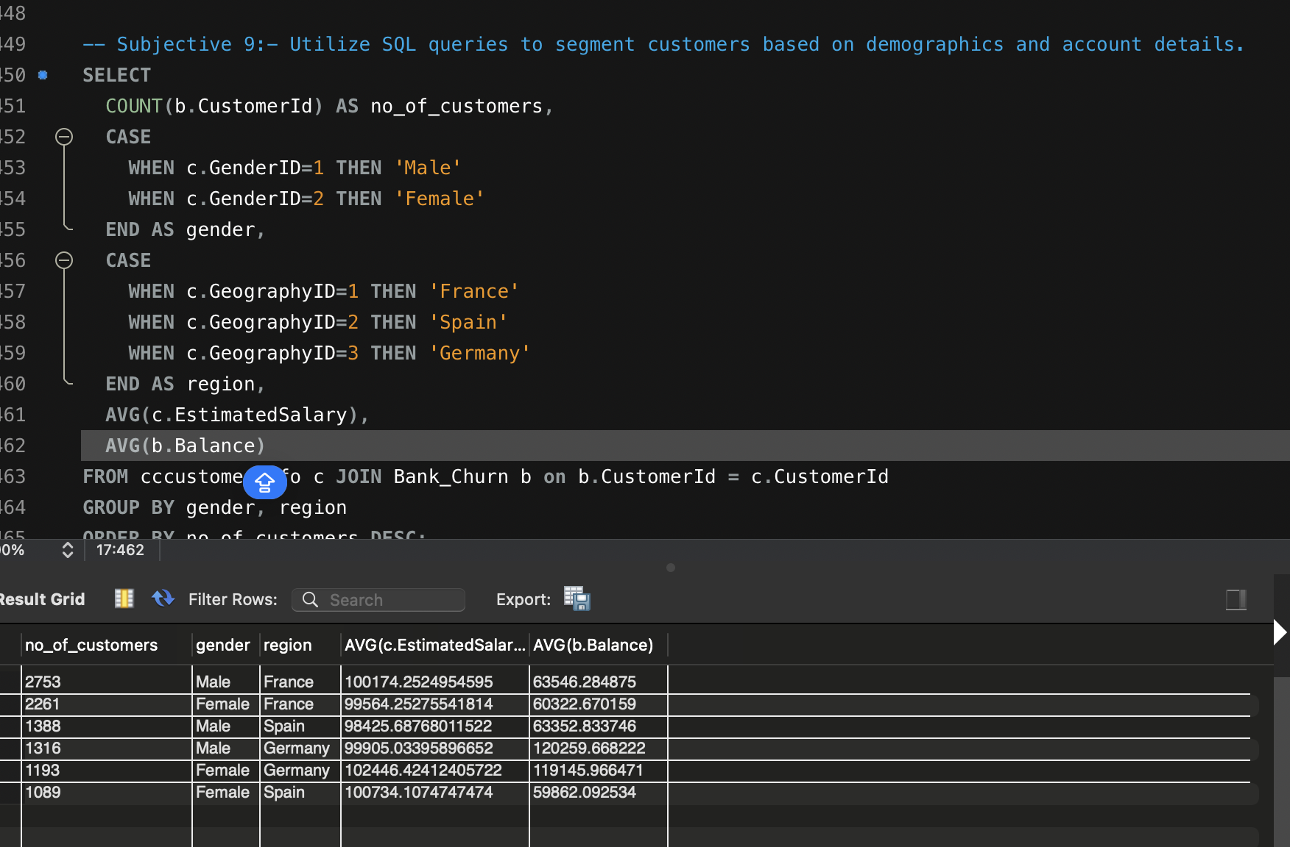

1. Insights:- As we can see that bank has maximum number of customers from France, followed by number of Female customers in France
2. Approach:-. In this we have joined two tables name cccustomerinfo and Bank_Churn on common column CustomerID and taken teh average estimated salary and balance of customers by region, that help us determine the customer segments based on demographics and account details.

**10.)How can we create a conditional formatting setup to visually highlight customers at risk of churn and to evaluate the impact of credit card rewards on customer retention?**

**Ans;- In the visualizations given below customers highlights in green shows less churn rate and customers in red shows higher churn rate.**

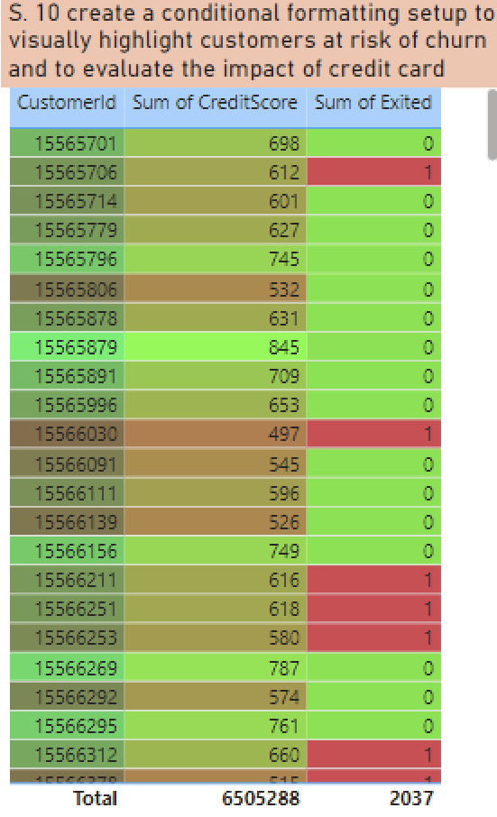

**11.) What is the current churn rate per year and overall as well in the bank? Can you suggest some insights to the bank about which kind of customers are more likely to churn and what different strategies can be used to decrease the churn rate?**

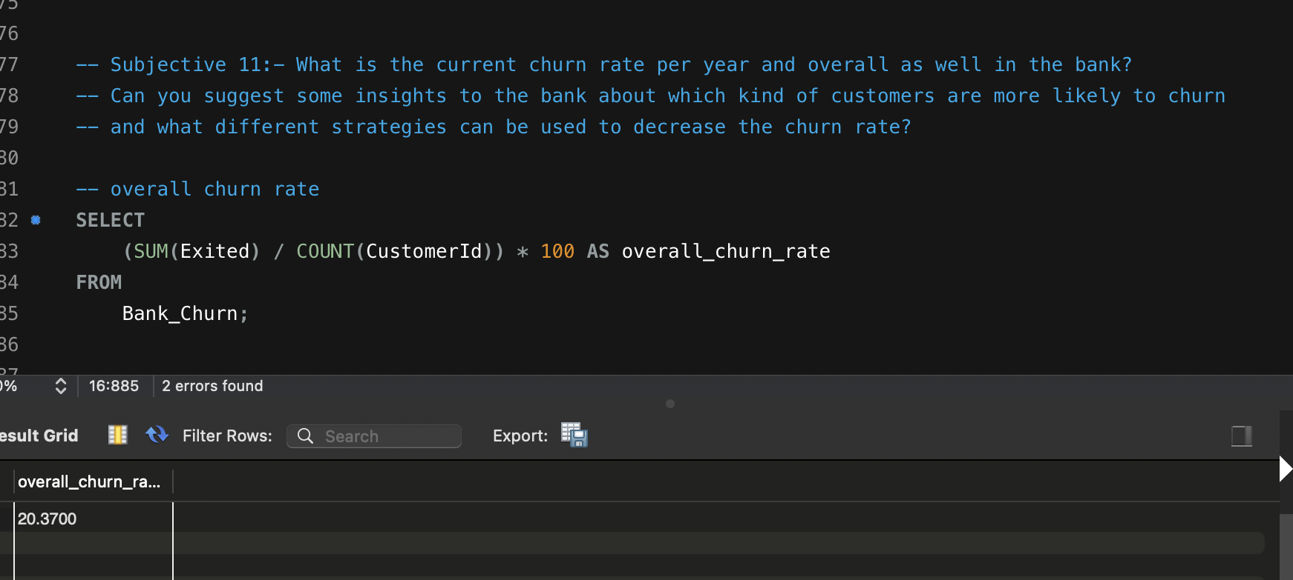

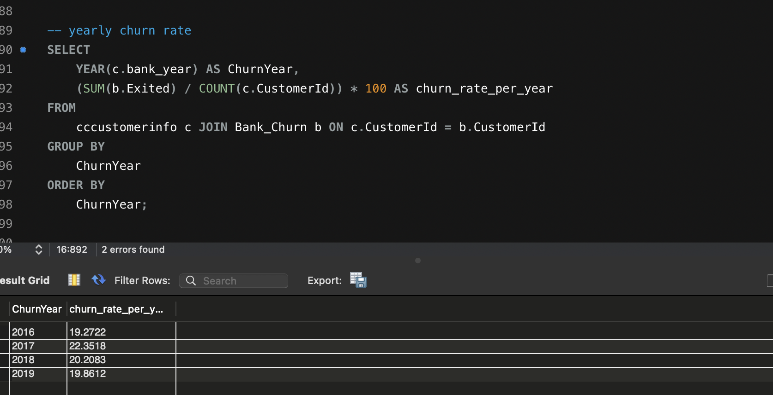

**For Yearly Churn Rate:-**

**As we can see from the data that customer churn rate on year by year starting from year 2016 to 2019 there is no trend that data is following . From 2016 to 2017 churn rate has increased by almost 3 % then decreased by 2 % and decreased by almost 1 %, there can be many factors affecting the churn churn rate social, economic etc.**

**Overall Chrun Rate:-**

**Overall churn rate of customer faced by bank is around 20.37 %. For this also there can be many factors affection the churn rate.**

**Recommendations:**

**To reduce the churn rate we can provide customer high credit card rewards on credit card usage and provide various types of loans such as home loan, education loan, car loan etc to customers at low interest and provide considerably high interest on saving account of customers.**

**12.) Create a dashboard incorporating all the KPIs and visualization-related metrics. Use a slicer in order to assist in selection in the dashboard.**

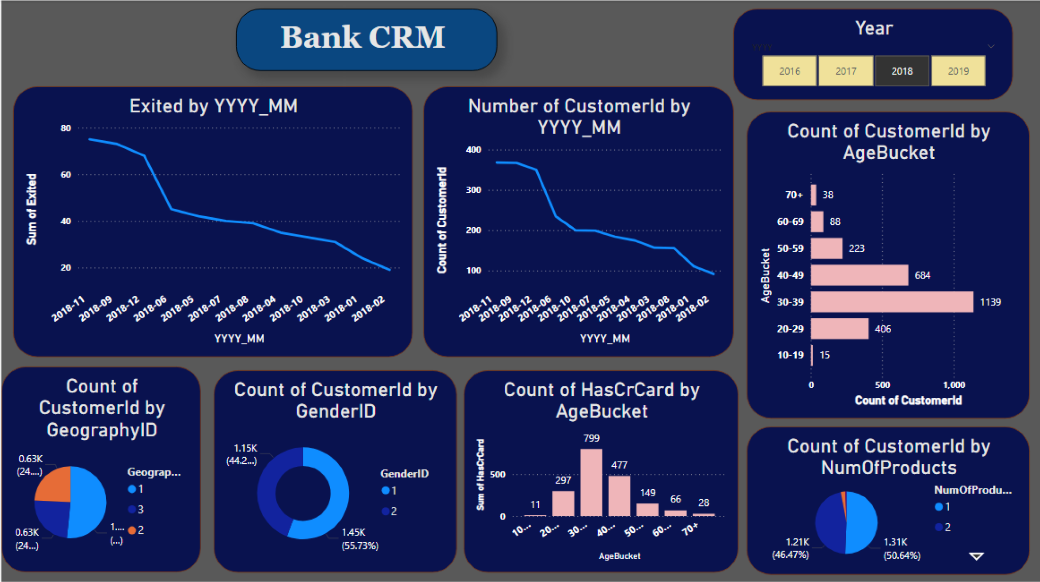

**In this using Power BI we have made a dashboard and various visualization related metrics that shows various KPIs to help us make data driven decision.**

**By using Power BI we can twist and turn data and see data from every angle and prospect that help make better decisions.**

**13.) How would you approach this problem, if the objective and subjective questions weren't given?**

**Ans:-**

When approaching a problem in Power BI without being provided with specific objective and subjective questions, the key is to break down the problem into manageable steps, focusing on understanding the data, asking relevant questions, and conducting targeted analyses. Here's how I'd approach it:

1. Understand the Data

Explore the dataset: Before formulating questions, understand what data is available. This includes identifying key fields, their types (categorical, numerical, time-based), and any relationships between them.

Assess data quality: Check for missing values, outliers, or inconsistencies that may need cleaning or transformations.

Example: If the dataset contains customer transactions, I would explore fields like CustomerID, PurchaseAmount, ProductCategory, and PurchaseDate.

2. Define the Problem Context

Without specific objectives, start by considering the domain the data comes from. Ask yourself:

What business area is this data related to?

For example, is it sales, customer churn, operations, or marketing?

Possible contexts:

Customer Churn Analysis: If you have customer-related data, the focus might be on understanding why customers leave.

Sales Performance: If it's sales data, you might analyze how well products are performing over time.

Operational Efficiency: If it’s operational data, the goal could be to find bottlenecks or inefficiencies.

3. Formulate Questions

Based on the data and its context, develop exploratory questions that will guide your analysis:

Descriptive Questions:

What is the distribution of key metrics like sales, churn, or product usage?

How does performance vary across regions, time, or customer demographics?

Diagnostic Questions:

What factors are contributing to a change in metrics (e.g., churn or sales decline)?

Are there correlations between certain variables (e.g., age and churn, or discount and sales volume)?

Predictive Questions:

Can we predict future sales based on past performance?

Can we identify customers who are likely to churn based on their behavior?

Prescriptive Questions:

What actions can we take to reduce churn or increase sales in underperforming regions?

Example: For customer churn data, some questions could be:

What is the churn rate across different regions?

Is there a correlation between customer tenure and the likelihood of churn?

Do customers with a higher balance or fewer products tend to churn more?

4. Conduct Analysis

Based on the questions formed, proceed with the analysis. Some key analyses might include:

Descriptive Statistics: Provide summary metrics (e.g., averages, medians, distributions) to understand the current state of the data.

Time-Series Analysis: If your data is time-based, analyze trends, seasonality, and patterns over time.

Correlation Analysis: Identify relationships between variables (e.g., age and churn, or discount and sales).

Segmentation: Group customers or data points into categories (e.g., high vs. low spenders, new vs. long-term customers).

Comparative Analysis: Compare key metrics across different groups (e.g., regions, product categories).

Drill-downs and Filters: Use drill-down capabilities to explore data at different granularities.

5. Visualize the Data

Use Power BI's capabilities to create intuitive and interactive visualizations that answer the formulated questions:

Bar/Column Charts: For categorical comparisons (e.g., sales per region or churn by product).

Line Charts: For time-based trends (e.g., monthly sales trends or customer churn over time).

Scatter Plots: To show correlations between variables (e.g., age vs. churn probability).

Maps: For geographic analysis (e.g., sales or churn distribution by location).

6. Refine Questions Based on Insights

As insights emerge from initial analyses, refine your questions:

Why is a particular region performing better or worse than others?

What customer behaviors are associated with increased spending or churn?

Which products or services are driving the most revenue or satisfaction?

7. Recommendations and Next Steps

Based on the analysis, provide actionable insights:

If a particular product is underperforming, recommend focusing marketing efforts on that product.

If churn is high among certain customer segments, suggest retention strategies like discounts or loyalty programs.

Example: Sales Performance Analysis

If you were working with sales data:

Descriptive questions: What are the top 5 best-selling products?

Comparative questions: How do sales compare across different regions?

Diagnostic questions: What time periods saw a decline in sales, and what factors might explain this?

Predictive analysis: Can we forecast future sales based on past performance?

By focusing on understanding the data, asking the right questions, and conducting exploratory and targeted analyses, you can approach any problem in Power BI, even without predefined objectives.

**14.)In the “Bank_Churn” table how can you modify the name of the “HasCrCard” column to “Has_creditcard”?**

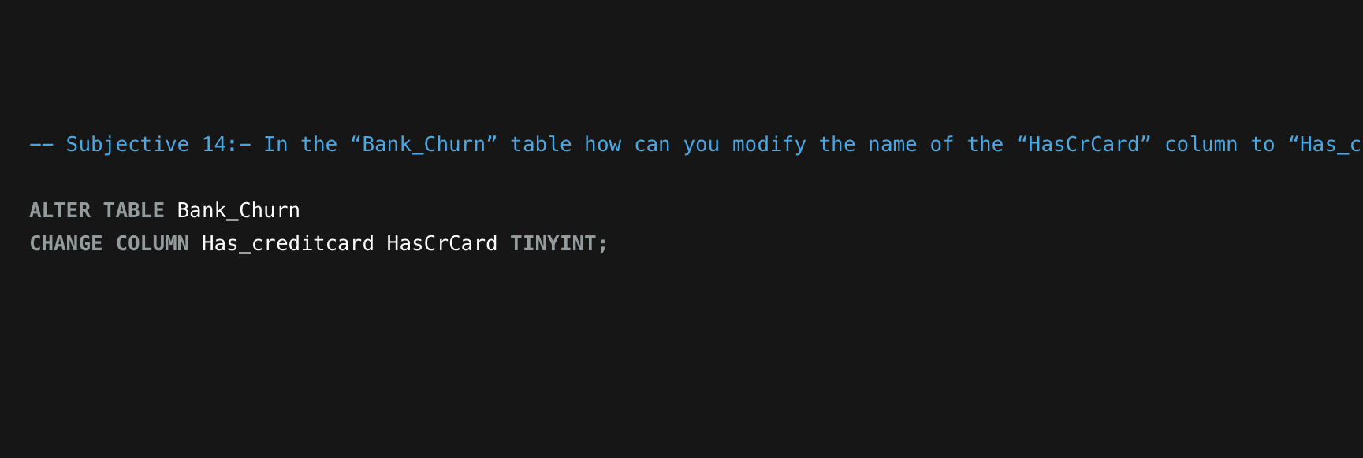

Solution : By using alter table Bank_Chrun

Change column new_name prev_name , we can change the column name of table.